Southern California Bight 2023 Regional Monitoring Program: Submerged Aquatic Vegetation (SAV)
SCCWRP Technical Report

Authors:
Southern California Coastal Water Research Project, Costa Mesa, CA

March 2023

BIGHT ‘23 SAV COMMITTEE
Member | Affiliation

FOREWORD
Citation
ACKNOWLEDGEMENTS

EXECUTIVE SUMMARY
Background
Regional monitoring is an important vehicle for understanding status and trends in aquatic habitat health in the Southern California Bight (SCB). One such important aquatic habitat in Southern California is eelgrass (Zostera sp.), which supports ecosystem functions, and by extension, supports Beneficial Uses and Essential Fish Habitat. Eelgrass plays a unique role in shaping coastal systems both physically and ecologically, as a baffle that stabilizes sediment and sequesters carbon, and a habitat that supports rich biodiversity of invertebrates, fish, and waterfowl (Nordlund et al 2016, Orth et al 1984). Most survey efforts across the state, including several regional inventories, focus on area and extent of eelgrass, and site-specific objectives (Merkel & Associates LLC, 2024). This approach does not directly consider the dual nature of SAV, as both an organism as well as a habitat, and the ecosystem functions supported by this complex living entity. Eelgrass presents an opportunity for a bioassessment approach that is tethered to a specific habitat, and is modeled around the functions of that ecosystem, rather than around the organisms that live within the habitat, which is a more common bioassessment approach (Mazor et al 2016; Anderson 2020).
Study Objectives and Approach
This study presents the findings of the first round of the Submerged Aquatic Vegetation (SAV) element of the Bight Regional Monitoring Program in 2023. This regional survey was motivated by the need to understand regional condition of eelgrass (Zostera marina), the dominant species of seagrass in Southern California, and whether or not that condition varies across different embayment types. A conceptual model proposed by McCune et al 2020 guided the structure of this evaluation. The conceptual model links seven ecosystem functions supported by SAV to the structural metrics that are measurable via field and lab surveys. These surveys were implemented through a community of practice, which developed and intercalibrated a series of standard protocols, and covered through a probabilistic sampling design, a subset of regional SAV habitat. A total of 59 sites across were surveyed across the region across three strata (small embayments, large embayments, estuaries). Structural metrics of eelgrass beds were measured and combined into a condition index comprised of ecosystem function scores. Each site received a condition score of either Poor, Moderate, Good or Excellent.
Study Findings
Our approach is the first of its kind – a regional survey of structural metrics of eelgrass across a number of embayments – and has culminated in a quantitative condition index that estimates supported ecosystem functions and overall condition of individual eelgrass beds.
Nearly half (45%) of the area Bight-wide is in Good Condition, and nearly a third (31%) of the remaining area is in Moderate Condition. Eelgrass overall condition did vary slightly across strata, with small embayments with more area in Moderate Condition, and large embayments/estuaries largely in Good Condition.
A major result of this study is the first quantitative application of an eelgrass condition index, which can be used to score individual eelgrass beds based on estimates of the ecosystem functions they support
Recommendations

TABLE OF CONTENTS

Bight ‘23 SAV Committee
Foreword
Acknowledgements
Executive Summary
Background
Study Objectives and Approach
Study Findings
Recommendations
Table of Contents
List of Figures
List of Tables
- Introduction
- Methods
  - Study Design
  - Field Collection of Structural Metrics
  - Laboratory Measurement of Structural Metrics
  - Index development
  - Additional Analyses
- Quality Assurance and Quality Control
  - Field
  - Laboratory
  - Data analysis
- Results
- Discussion
- Conclusions
- Recommendation
- Literature Cites
Appendix A – Eelgrass structural metrics
Appendix B – Eelgrass index and function scores by waterbody
Appendix C – Maps of eelgrass condition
Appendix D – Exploratory Analyses

List of Figures
Figure 2. Schematic depicting the transect and quadrat sampling scheme for different growth forms of eelgrass. A The idealized Bed, B – The Idealized Patch, C – Th e Idealized Fringing Bed, and D – The Idealized Meadow. Any intertidal portions of given location were omitted from sampling.
Figure 3. Conceptual model of relationships between structural metrics and ecosystem functions of seagrass (McCune et al. 2020).
Figure 4. Percent area estimates (with 95% confidence intervals) of overall eelgrass condition score by stratum. The points represent area estimates and the error bars represent the strata-based confidence intervals.
Figure 5. Geographic distribution of overall eelgrass condition throughout the Southern California Bight. The legend shows point color corresponding to overall eelgrass condition categories.
Figure 6. Percent area estimates (with 95% confidence intervals) of the seven ecosystem function scores in each of the four condition categories. Points represent area estimates, and error bars represent strata-based confidence intervals.
Figure 7. Percent area estimates (with 95% confidence intervals) of each of the seven ecosystem function scores in each of the four condition categories. Points represent area estimates and error bars represent strata-based confidence intervals.
Figure 8. Non-metric multidimensional scaling plot of ecosystem function scores at each waterbody. Points represent centroids from multiple sites at each waterbody. Points and ellipses are both color-coded by waterbody. Ellipses represent 95% of the data for each waterbody. Stress = 0.041.
Figure 9. Total Suspended Solids (TSS) in milligrams per 500 mL water versus water quality ecosystem function scores. TSS data was not available for all sites. Geom_smooth() represents the 95% confidence interval for this observed relationship.
Figure 10. Overall eelgrass index scores with distance to inlet (km).
Figure 11. Overall eelgrass condition scores by nominal site protection status. P = “protected”, “U” = unprotected. Protected sites include areas within designated Marine Protected Areas (no take, limited take, State Marine Reserves, State Marine Conservation Areas). Unprotected sites are areas that are not protected from take in some way, including National Wildlife Refuges. Significant difference between groups via Wilcox test (p = 0.049).
Figure 12. Geographic distribution of estimated water quality ecosystem function throughout the Southern California Bight. The legend shows point color corresponding to water quality condition categories.
Figure A1. Eelgrass structural metric data by stratum – part 1.
Figure A2. Eelgrass structural metric data by stratum – part 2.
Figure C1. Geographic distribution of estimated nekton habitat ecosystem function throughout the Southern California Bight. The legend shows point color corresponding to overall eelgrass condition categories.
Figure C2. Geographic distribution of estimated waterfowl habitat ecosystem function throughout the Southern California Bight. The legend shows point color corresponding to overall eelgrass condition categories.
Figure C3. Geographic distribution of estimated carbon sequestration ecosystem function throughout the Southern California Bight. The legend shows point color corresponding to overall eelgrass condition categories.
Figure C4. Geographic distribution of estimated substrate stabilization ecosystem function throughout the Southern California Bight. The legend shows point color corresponding to overall eelgrass condition categories.
Figure C5. Geographic distribution of estimated primary production ecosystem function throughout the Southern California Bight. The legend shows point color corresponding to overall eelgrass condition categories.
Figure C6. Geographic distribution of estimated secondary production ecosystem function throughout the Southern California Bight. The legend shows point color corresponding to overall eelgrass condition categories.
Figure D1. Two-dimensional non-metric multidimensional scaling (nMDS) ordination of ecosystem function scores at each site. Ellipses represent 95% of the data for each waterbody. Stress = 0.041.
Figure D2. Log₁₀ – transformed chlorophyll a concentrations with overall eelgrass index scores. Chlorophyll data was not available for all sites. No significant relationship was observed.
Figure D3. Overall eelgrass condition scores by nominal site protection status. P = “protected”, “U” = unprotected. Protected sites include areas within designated Marine Protected Areas (no take, limited take, State Marine Reserves, State Marine Conservation Areas). Unprotected sites are areas that are not protected from take in some way, including National Wildlife Refuges. T-test comparisons indicate no significant differences between protection status in any stratum.
Figure D4. Overall eelgrass condition scores by specific site protection status. “No Take” = MPAs with no take, “Limited Take” = MPAs with limited take regulations, not including scientific collection, “NWR” = National Wildlife Refuges, “U” = unprotected. Wilcox test shows a significant (p = 0.02) difference between NWR and Unprotected sites.
Figure D5. Overall eelgrass condition scores by specific site protection status. “No Take” = MPAs with no take, “Limited Take” = MPAs with limited take regulations, not including scientific collection, “NWR” = National Wildlife Refuges, “U” = unprotected. Wilcox test shows a significant (p = 0.0089) difference between NWR and Unprotected sites in estuaries only.

List of Tables
Table 1. List of sites, waterbodies, and site selection method.
Table 2 Eelgrass plant and bed-scale metrics measured as part of this protocol and which step details their collection.
Table 3. QA/QC summary based on submitted data. Exercise in gathering information about the nature of errors that arise in a community of practice.
Table 4. Lessons learned from field based on Bight ‘23 SAV Committee feedback.
Table B1. Site by site ecosystem function scores and overall eelgrass condition scores.
Table B2. Overall eelgrass condition scores by waterbody
Table B3. Percent area-weighted ecosystem function scores by stratum, including upper and lower 95% confidence intervals.
Table B4. Percent area-weighted overall eelgrass condition scores by stratum, including upper and lower 95% confidence intervals.
Table B5. Percent area-weighted estimated ecosystem function scores for the overall Bight, including upper and lower 95% confidence intervals.

- Introduction
- SAV overall ecological importance
- SAV in SCB habitats
- Structure to function relationship
- How SAV fits in with regional monitoring + need for condition tool
- Methods
  - Study Design
A stratified probabilistic sampling approach was used to sample eelgrass beds throughout the Southern California Bight such that inferences may be drawn from the sampled population of eelgrass to the true population of eelgrass. A base map layer from Point Conception, CA to the US-Mexico border was generated from previous surveys of eelgrass beds across the region from 2015-2022 (Merkel and Associates, 2016; Merkel and Associates 2023). This base map was augmented with waterbody-by-waterbody site visits focusing on smaller, heretofore under sampled embayments in the northern parts of the Southern California Bight (e.g., Hollister Ranch lagoon, Gaviota estuary, Refugio estuary) looking for eelgrass in the summer of 2022. These small embayments were surveyed for the presence of eelgrass by paddling and snorkeling (when practical) their waters, recording the presence and type of any SAV that was observed. These observations were then digitized into polygons for inclusion into the base map. Lastly, the base map was amended following consultations with local seagrass experts across the region. All of these eelgrass extent and presence data were combined into a single GIS data layer from which sample sites could subsequently be selected. (https://sccwrp.maps.arcgis.com/apps/webappviewer/index.html?id=fbd66a9bc6174ad7a5cf90b3d5b9405c).
Each waterbody along the Southern California Bight was binned into one of three strata prior to sampling (Gillett et al. 2018), based on environmental setting (Doughty 2019) and local knowledge.
- Large embayments – Enclosed or semi-enclosed waterbodies greater than 8 km² in area that have a permanent connection to the open ocean (e.g. San Diego Bay, Lower Newport Bay).
- Small embayments – Enclosed or semi-enclosed waterbodies less than 8 km² in area that have permanent connections to the open ocean (e.g. Newport Back Bay, Marina del Ray).
- Estuaries – Small enclosed waterbodies with a distinct connection to upland freshwater sources and permanently maintained or seasonal/ephemeral connection to the open ocean (Anaheim Bay, Batiquitos Lagoon).
The sample frame of the previously observed eelgrass area in each stratum was divided into 500m² cells that would represent a potential sample site. Ten sample sites were randomly selected without replacement from each stratum (30 in total) using the sample_strat function in the R package spSurvey (v5.5.1) (Dumel et al 2023). Given the ephemeral nature of eelgrass aggregations that expand and contract in extent from year to year, 30 additional sites were identified for each stratum to serve as replacement sites (i.e., overdraw sites) in case any of the initial 10 sample sites did not have any vegetation in 2024. Eleven additional sites of special concern were identified according to management priority, after the probabilistic sample draw. These sites were surveyed and then assigned a stratum based on their respective waterbodies.
Table 1. List of sites, waterbodies, and site selection method.
waterbody | masterid | stratum | site selection
Agua Hedionda Lagoon | 904AHT001 | estuary | probabilistic
Batiquitos Lagoon | 904BLT001 | estuary | probabilistic
Mission Bay | 906MBECSR | large_embayment | probabilistic
Mission Bay | 906MBMCSC | large_embayment | probabilistic
Mission Bay | 906MBVCSA | large_embayment | probabilistic
Mission Bay | 906MBVINC | large_embayment | probabilistic
Mission Bay | 906MBVIYP | large_embayment | probabilistic
San Diego Bay | 910ZNJN01 | large_embayment | probabilistic
San Diego Bay | 910ZNJN02 | large_embayment | probabilistic
San Diego Bay | 912SDBCPB | large_embayment | probabilistic
San Diego Bay | 912SDBSLB | large_embayment | probabilistic
San Diego Bay | 912SDCBVP | large_embayment | probabilistic
San Diego Bay | 912SDNOST | large_embayment | probabilistic
San Diego Bay | 912SDSBPO | large_embayment | probabilistic
San Diego Bay | 912SDSIWB | large_embayment | probabilistic
San Diego Bay | 912SDSSSC | large_embayment | probabilistic
San Diego Bay | 912SDT001 | large_embayment | probabilistic
San Diego Bay | 912SDT003 | large_embayment | probabilistic
Santa Ana River | B23-SAV-001 | estuary | probabilistic
Batiquitos Lagoon | B23-SAV-002 | estuary | probabilistic
Seal Beach NWR (Case Pond) | B23-SAV-005 | estuary | probabilistic
Seal Beach NWR | B23-SAV-006 | estuary | probabilistic
Batiquitos Lagoon | B23-SAV-007 | estuary | probabilistic
Agua Hedionda Lagoon | B23-SAV-008 | estuary | probabilistic
Seal Beach NWR | B23-SAV-009 | estuary | probabilistic
Port of Los Angeles | B23-SAV-011 | small_embayment | probabilistic
Huntington - Magnolia Marsh2 | B23-SAV-012 | small_embayment | probabilistic
Magnolia Marsh | B23-SAV-012 | small_embayment | probabilistic
Newport Bay | B23-SAV-014 | small_embayment | probabilistic
Port of Los Angeles | B23-SAV-015 | small_embayment | probabilistic
Newport Bay | B23-SAV-018 | small_embayment | probabilistic
Port of Los Angeles | B23-SAV-020 | small_embayment | probabilistic
San Diego South Bay | B23-SAV-022 | large_embayment | probabilistic
San Diego Bay | B23-SAV-023 | large_embayment | probabilistic
Newport Bay | B23-SAV-025 | large_embayment | probabilistic
San Diego Bay | B23-SAV-026 | large_embayment | probabilistic
San Diego South Bay | B23-SAV-027 | large_embayment | probabilistic
San Diego Bay | B23-SAV-029 | large_embayment | probabilistic
San Diego South Bay | B23-SAV-030 | large_embayment | probabilistic
Newport Bay | B23-SAV-031 | small_embayment | probabilistic
Bolsa Chica | B23-SAV-032 | estuary | probabilistic
Batiquitos Lagoon | B23-SAV-035 | estuary | probabilistic
San Diego Estuary | B23-SAV-036 | estuary | probabilistic
San Dieguito Lagoon | B23-SAV-060 | estuary | probabilistic
Magnolia Marsh | B23-SAV-063 | small_embayment | probabilistic
Port of Los Angeles | B23-SAV-064 | small_embayment | probabilistic
Dana Point Harbor | B23-SAV-066 | small_embayment | probabilistic
Mission Bay | B23-SAV-092 | large_embayment | probabilistic
Alamitos Bay | B23-SAV-901 | small_embayment | targeted
Alamitos Bay | B23-SAV-902 | small_embayment | targeted
Alamitos Bay | B23-SAV-903 | small_embayment | targeted
Alamitos Bay | B23-SAV-904 | small_embayment | targeted
San Diego Bay (Zuniga Jetty) | B23-SAV-905 | large_embayment | targeted
Mission Bay | B23-SAV-906 | large_embayment | targeted
San Elijo Lagoon | B23-SAV-907 | estuary | targeted
Mission Bay | B23-SAV-908 | large_embayment | targeted
King Harbor | B23-SAV-909 | small_embayment | targeted
Oceanside Harbor | B23-SAV-910 | small_embayment | targeted
La Jolla Cove | B23-SAV-991 | NA | targeted
Santa Cruz Island | B23-SAV-Santa Cruz Island | NA | targeted

  - Field Collection of Structural Metrics
Field protocols for sampling are fully detailed in McCune et al. (2020). All in-water measurements and collection of material were conducted by teams of SCUBA divers and any intertidal portions of a location were omitted from sampling. If seagrass was present at a site, the perimeter of the aggregation was measured. Plants were considered to be of the same aggregation if there was less than 5m of bare sediment between plants. Eelgrass was classified into different growth categories:
- Patch – Eelgrass aggregation 3m or less on the longest axis
- Bed – Eelgrass aggregation between 5 and 60m along its longest axis and at least 5m along its cross axis (typically shallowest point to deepest point)
- Fringing Bed – Eelgrass aggregation between 5 and 60m along its longest axis and less than 5m along its cross axis
- Meadow – Eelgrass aggregation larger than a bed
For the bed growth category, a transect (maximum 50m long) was laid along its longest axis (mid transect) and second transect was laid from the shallowest subtidal point to the deepest point (cross transect) that was roughly perpendicular to the mid transect. See Figure 1 for sampling scheme in each of the different growth categories. Starting at the beginning edge of the mid transect, 0.25m² quadrats were placed every 10m (i.e., a maximum of 5 mid transect quadrats) on the sediment surface. Similarly, quadrats were placed at the shallow and deep ends of the cross transect. At each quadrat, % cover of seagrass was visually estimated, as was % of drifting macroalgae. Shoot density was estimated by counting all of the distinct eelgrass shoots within the quadrat. Flowering shoot density was estimated as the number of shoots within the quadrat with distinct spathes (leaf structures that enclose the flowers) on their upper ends. For sites classified as patches, 1 or 2 0.25m² transects were haphazardly placed within the patch, depending on the size of the patch. For sites classified as meadows, a 50m X 20m area was identified and transects and quadrats were placed as normal. For sites classified as fringing beds, only a mid transect was used.
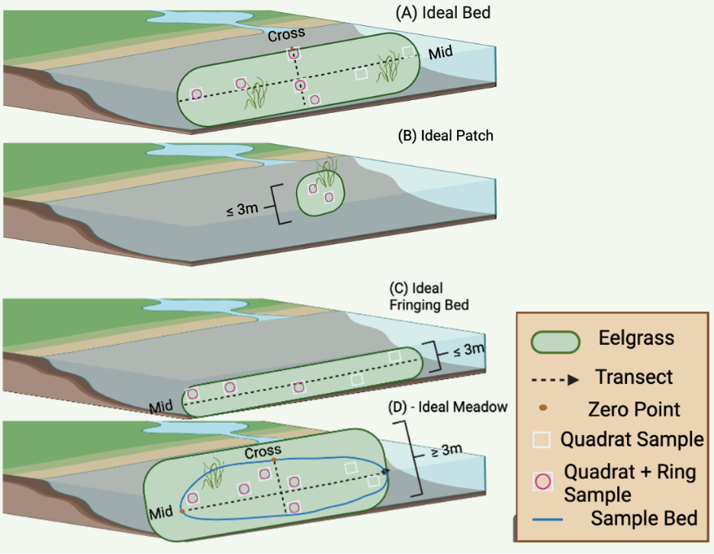
Figure 2. Schematic depicting the transect and quadrat sampling scheme for different growth forms of eelgrass. A The idealized Bed, B – The Idealized Patch, C – Th e Idealized Fringing Bed, and D – The Idealized Meadow. Any intertidal portions of given location were omitted from sampling.
At sites classified as beds, eelgrass material was collected for subsequent lab analyses from the first 3 mid transect quadrats and 2 cross transect quadrats. A 10cm i.d. ring was placed in the middle of the quadrat. All above ground material (i.e., shoot base, leaves, and attached epiphytes) within the ring were cut at the sediment surface and placed in sample bags. All below ground material (i.e., roots and rhizomes) within the diameter of the ring were cut, removed from the sediment, gently rinsed, and placed in sample bags. For sites classified as patches, above and below ground material was collected within each quadrat. For sites classified as fringing beds, material was only collected from the first 3 mid transect quadrats. Sites classified as meadows, were sampled the same as bed sites. Further details, including SOPs, can be found in the B23 SAV Workplan document.

  - Laboratory Measurement of Structural Metrics
Within the above ground material from a given site and quadrat, the total number of shoots and the number of leaves per shoot were recorded. All epiphytic material was gently removed from each leaf with a scalpel or glass microscope slide and pooled together for biomass measurement. The length of the of the longest leaf within each shoot was recorded as shoot height and the width of that longest leaf was recorded as shoot width. The total area of all the leaves in each shoot was measured with a leaf area meter (LI-COR™ LI-3100C Area Meter) or a calibrated benchtop scanner and ImageJ image analysis software (https://imagej.net/ij/) and recorded as leaf area. All epiphytic tissues, above ground eelgrass tissue, and below ground eelgrass tissue were blotted dry and measured for wet mass. Each type of tissue was then dried at 60°C for 48 hours and measured for dry mass. A subsample of approximately 2.5 - 3 mg was clipped from each dried tissue sample to measure TOC/TN. Dried samples were subsequently combusted at 500°C for 8 hours and measured for ash free dry mass. The mass of each TOC/TN subsample was multiplied by the ash:dry mass ratio to produce a corrected AFDM for each tissue type, to correct for the removal of tissue. Further details, including SOPs used in this study and proposed for future studies, can be found in the B23 SAV Workplan document.

Table 2. Eelgrass plant and bed-scale metrics measured as part of this protocol and which step details their collection.
Metric | Field or Lab Data Generation | SOP Step
Above Ground Biomass | Lab | Step 19
Above Ground C & N | Lab | Step 21
Bed Perimeter | Field | Step 4
Below Ground Biomass | Lab | Step 19
Below Ground C & N | Lab | Step 21
Epiphyte Biomass | Lab | Step 16
Leaf Area | Lab | Step 18
Leaves per Shoot | Lab | Step 17
Percent Cover | Field | Step 7-3
Sediment C & N | Lab | Step 21
Shoot Density | Field and Lab | Steps 7-4 & 14
Shoot Height | Field and Lab | Steps 7-5 & 15

  - Index development
Eelgrass condition was quantified using the framework outlined in McCune et al. 2020 and refined using the SCCWRP Regional Eelgrass Survey of Condition and Quality (RESCQ) project data (Table 1). Both Bight and RESCQ Zostera marina structural metrics datasets (89 sites in total) were included in the calibration of the index. Overall condition and individual ecosystem function condition presented here are only for sites as part of the Bight survey. More information regarding the RESCQ survey can be found here (LINK – RESCQ Tech Memo/Final Report).
In brief, individual structural metrics (e.g. shoot height, shoot density, leaf area) were binned into quartiles based their position in the regional dataset (1 = lowest quartile, 4 = highest quartile). These quartile scores were then combined for each of the seven ecosystem function (e.g. primary production, carbon sequestration, substrate stabilization) based on available data and averaged (Table 1). Ecosystem function scores (1-4) were then binned into four categories (Poor, Moderate, Good, Excellent) based on the regional dataset (scores 1.00 to 1.75 = Poor; scores 1.76 to 2.50 = Moderate; scores 2.51 to 3.25 = Good; score 3.26 to 4 = Excellent). All seven ecosystem function scores were averaged together for each site, representing the Overall Condition score, which was binned into the same four condition categories as described above.
  - Additional Analyses
We explored the responsiveness of the eelgrass index based on data availability and Bight committee interest. As a group, the main interest was to evaluate the index’s response to stressors or known “reference conditions”. Data from concurrently taken water samples measured for Total Suspended Solids (TSS) and chlorophyll a was used opportunistically to evaluate index response to potential stressors. Measurements of TSS and chlorophyll a were not available for all sites. Overall, it was hypothesized that if a large enough range in these water quality measurements was observed, the eelgrass index may show a response to chlorophyll and/or TSS as eelgrass stressors.
Additionally, distance from nearest inlet (km) from each site to the threshold of the closest inlet “as the fish swims” was measured using ArcGIS. While we acknowledge that distance from inlet is not a direct measurement of any particular stressor, and is only a cursory approximation of confounding estuarine conditions, it may offer some insight to eelgrass condition. It was hypothesized that eelgrass very far away from the inlet (within an estuary) may experience more stress as a function of its proximity to runoff from the land and higher residence time of polluted water.
Each site was also categorized, based on its location relative to a Marine Protected Area, as either “No Take”, “Limited Take” or “Unprotected”, based on activities permitted in each MPA. A few remaining sites were categorized as “National Wildlife Refuge”. Site protection categories were determined by overlaying the site coordinates with California Department of Fish and Wildlife’s Interactive MPA Map. Overall, it was hypothesized that the level of site protection may be reflected in the estimated eelgrass condition, either based on protection offering better eelgrass condition, or perceived quality of eelgrass condition influencing management protection decisions.
Relationships between estimated eelgrass condition and the aforementioned response variables were explored using linear regressions and pairwise comparisons (Wilcox tests), as appropriate.
- Quality Assurance and Quality Control
The goal of the QA/QC effort explored in this first round of data collection across the Southern California Bight was to ensure the data generated by study participants was comparable and complete. Through quality control practices such as field intercalibration, field and lab resampling, and error tracking, we ensure high data quality for subsequent analyses. Each quality control practice is summarized in the subsections below. Full details can be found in the B23 SAV Workplan.
  - Field
Before data collection in 2023, a field intercalibration was hosted in April 2024 to ensure quality of visual data recorded was consistent across participating laboratories. Labs included CSULB, NOAA Fisheries, Merkel & Associates, LLC, Moss Landing Marine Lab, Paua Marine, and Marine Taxonomic Services LTD. As part of this exercise, teams of divers were asked to perform observational quadrat surveys (three transects, five points along each transect, two different beds). This included (1) taking a photo, and (2) recording percent cover of eelgrass and shoot count, and (3) recording water depth from a diver’s computer. Results from each team were compared as a learning exercise. In addition to practicing field data collection, SOPs were also discussed and clarified prior to official data collection. CHRISTINE’S FIELD DETAILS.
Field replicates were included in the Workplan to represent 10% of the total number of beds. Duplicate visual surveys as well as above and belowground eelgrass collections were proposed at these points as a QA/QC measure. Due to time and tidal constraints, as well as diminished visibility after the first visual survey, only one true field replicate was taken. High quality field data was still anticipated given the reproducibility of data from the field intercalibration as well as the comparability of the one field replicate. Several concurrent field replicate measures were proposed in the original workplan but were not taken during this Bight cycle due to logistical or funding constraints. This included infauna collection and sediment collection, which were excluded altogether from data collection, but are proposed for future Bight SAV efforts.

  - Laboratory
The primary objective of laboratory quality assurance measures was to understand both reproducibility of data and sources of error. A target of 10% of observational measurements were re-measured in the lab and labeled as laboratory replicates. Re-measurement of these replicates included: shoot count, leaves per shoot, shoot height, shoot width, and leaf area. When available, the field replicates were used as additional laboratory replicates to remeasure epiphyte biomass, aboveground, and belowground biomass. This resampling approach lays the foundation for future Data Quality Objectives for a more quantitative approach to quality assurance and control of data.

  - Data compilation and analysis
Post-data collection, we further explored the nature of errors and problems through group discussion to document improvement for future monitoring efforts. Errors and their sources were also tracked in data compilation (Table). As a general rule, most discrepancies were fixable unless they involved missing data not collected either in the field or in the lab after a sample had been already dried. Future data collections will be done through a data portal, which will circumvent most of these issues through a series of quality checks prior to submission.
Lessons learned were also tracked using an online feedback form and discussed with the Bight SAV Committee (Table) . These lessons will be implemented into the proposed Workplan for future Bight cycles and other SAV project.
Table 3. QA/QC summary based on submitted data. Exercise in gathering information about the nature of errors that arise in a community of practice.
Category | Discrepancy | Counts | Fixable
Unclear SOP | Mislabeled site | 1 | 1
 | Data not collected | 7 | 0
 | Duplicate (field) | 1 | Not needed
 | Reason for overdraw not documented | 3 | 3
 | Overdraw replacement not documented | 2 | 2
Misinterpretation/translation error | Duplicate | 3 | 3
 | Mislabeled data point | 15 | 15
Missing item | Missing datapoint | 4 | 0
 | Missing date | 3 | 3
 | Missing site label | 10 | 10

Table 4. Lessons learned from field based on Bight ‘23 SAV Committee feedback.
Issue | Category | Potential solution | Analysis needed to move forward
Cross3parallel method too time-consuming | Modification requested | Rely on cross-parallel method | Within-bed variability study comparing both methods (completed)
Two diver passes per quadrat result in marked loss of visibility for second diver | Modification requested | One pass only | Establish DQO to define and control error rates between divers
Potential team-to-team variability | Identification of potential issue | Build in more preset quadrat stations for future intercalibration exercises | Same as solution
Meadow protocol eliminates edge effects | Identification of potential issue | Consider mapping a standard area for all bed types | Comparison between standard area data (future) and non-standard area (current data)

Figure 3. CONCEPTUAL MODEL
Results
2023 Eelgrass condition assessment
Most of the surveyable eelgrass area within the Southern California Bight was classified by the eelgrass index as in either Good Condition (45.55%) or Moderate Condition (30.95%) (Figure 4, Table B3). On either extreme, 12.37% of the area Bight-wide was in Poor Condition and 11.17% was in Excellent Condition. Overall eelgrass condition differed across strata, with 58.82% of area in the small embayment strata in Moderate Condition. The other two strata showed a different pattern, with 48.15% and 35.76% of area in the large embayment and estuary strata, respectively, classified in Good condition. All strata had their smallest percentage (less than 15% in all strata) of area in Excellent Condition. Estuaries had the largest area of any stratum (21.41%) in Poor Condition. Full site list with condition categories can be found in Appendix B.
No waterbodies were classified in Excellent Condition, but four waterbodies were in overall Poor Condition (Alamitos Bay, Seal Beach NWR (Case Pond), San Elijo Lagoon, and Santa Ana River) (Table B2). However, there were total of six individual sites classified in Excellent Condition and nine individual sites classified in Poor Condition (Figure 5).

Estimated ecosystem function overall and across strata
Estimated Carbon Sequestration (29.43%), followed by Waterfowl Habitat (16.94%) ecosystem functions had the highest percent area Bight-wide in Excellent Condition (Figure 6, Table B5). Estimated Primary Production (3.47%) and Secondary Production (5.71%) had the lowest percent of area Bight-wide in Excellent Condition (Figure 6, Table B5). Secondary Production (57.64%), followed by Primary Production (47.13%), and Substrate Stabilization (39.17%), had the largest amount of area in Good Condition. All other ecosystem functions had their largest amount of area in Moderate Condition.
Six out of seven ecosystem functions in small embayments had the most area classified in Moderate Condition, with most area in the Carbon Sequestration function classified as Poor Condition (Figure 7). Four out of seven ecosystem functions in large embayment had the most area classified in Moderate Condition, with most area in the Substrate Stablilization, Primary Production, and Secondary Production function classified as Good condition (Figure 7). In estuaries, Waterfowl Habitat had the most area classified in Excellent Condition. In contrast, Carbon Sequestration in estuaries had the most area in Poor Condition (Figure 7). Maps of each estimated ecosystem function across the Southern California Bight can be found in Appendix C. Tables of ecosystem function scores across strata and across the SCB can be found in Appendix B.
Overall condition category was associated with the NMDS1 axis, with waterbodies scoring in Poor Condition (Seal Beach NWR (Case Pond), Santa Ana River, Alamitos Bay and San Elijo Lagoon) separating to one side of the ordination (Figure 8). Waterbodies with Good overall condition scores (Agua Hediona Lagoon, Batiquitos Lagoon, Magnolia Marsh, Mission Bay, San Diego Bay (Zuniga Jetty), and Oceanside Harbor) separated to the opposite side of the ordination (Figure 8). Ecosystem functions associated with each axis were evaluated using the envfit() function in the vegan package (CITATION). Substrate stabilization, Secondary Production, and Water Quality had the strongest negative associations with the NMDS1 axis (p-value < 0.001). Carbon Sequestration, Waterfowl Habitat, and Nekton Habitat had the strongest associations with the NMDS2 axis (p-value < 0.001). Carbon sequestration had a positive association with NMDS2 axis and Nekton Habitat and Waterfowl Habitat ecosystem functions had a negative association with the NMDS2 axis.
Index responsiveness to potential stressors and natural gradients
Opportunistically measured potential stressors were used to partially validate the eelgrass condition index’s responsiveness to stress. An ideal index is unresponsive to natural environmental gradients, but shows differences in scores according to potential stressors, including pollution in the form of chemicals and/or eutrophic conditions. Chlorophyll a (ug/L) and TSS (mg/L) were used to explore responsiveness of the eelgrass index to these potential stressors. Likewise, distance to inlet (as-the-fish-swims), central depth (Mean High Water adjusted), and nominal site protection status (MPA vs. non-MPA) were also used to explore index response to natural gradients/potential indicators of good ecosystem health.
Log₁₀-transformed chlorophyll a concentrations showed no significant relationship (p = 0.65) with overall eelgrass condition (Figure D2). The range of TSS (mg/L) measured throughout this study was 0 – 60 mg per 500 mL, with all but two sites ranging between 20-40 mg per 500 mL. No significant relationship was observed between TSS concentrations and overall eelgrass condition scores. A linear regression (y = -0.023x + 3.3) showed a slight decrease in water quality function score with increasing TSS, though not statistically significant (p=0.072). Complete results for exploratory analyses can be found in Appendix D.
Central depth (m) had no significant linear relationship with overall eelgrass index score. However, distance-to-inlet had a significant (p = 3.25 x 10⁻⁴) negative relationship with overall score. When separated by strata, only overall index scores estimated in large embayments demonstrated this trend of higher scores in areas closest to the inlet (Figure 10). Index scores in small embayments and estuaries did not change with distance to inlet. With only one site as an exception, only large embayments had distances from inlet greater than 6 km, by nature of the size of the measured embayments.
Site protection status was considered at the level of Protected vs. Unprotected based on site MPA status, and on a more granular level (No Take, Limited Take, National Wildlife Refuge, Unprotected). There was only one significant difference, observed between Unprotected and NWR sites (p = 0.02) at granular level. However, the distribution of data across protection status and strata is uneven, indicating a potential site-specific signal rather than an overall pattern of protection status impacting eelgrass index scores. At the nominal protection status level (Protected vs. Unprotected), the distribution of data was more even across statuses. A significant difference based on Wilcox test comparisons indicate a significant (p = 0.049) difference between unprotected and protected areas (Figure 11). Complete results for exploratory analyses can be found in Appendix D.

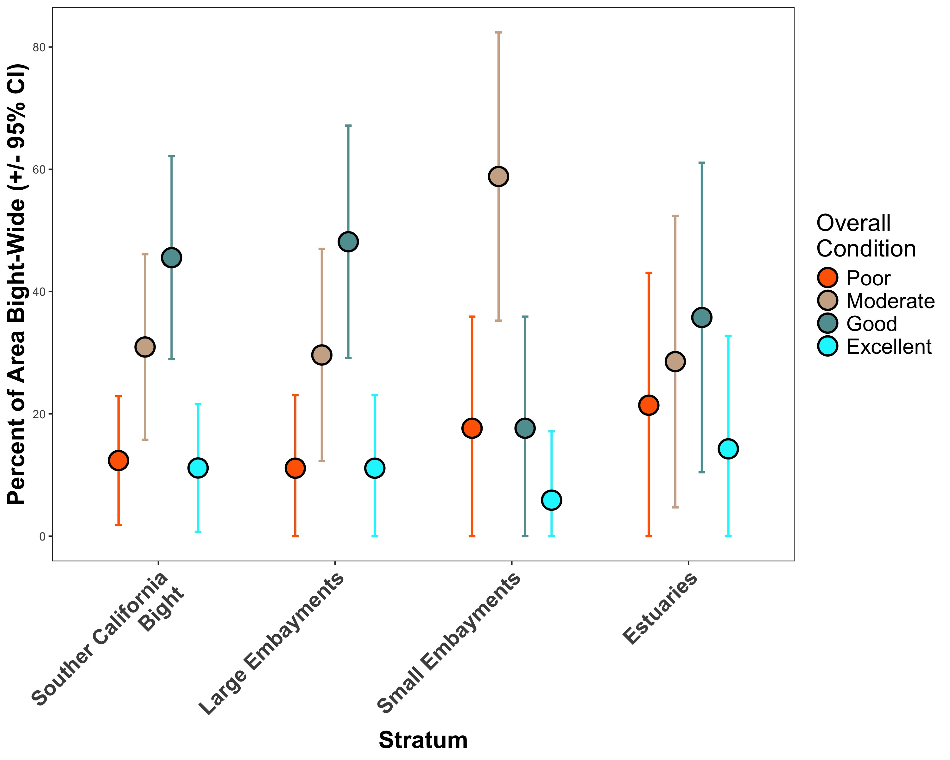
Figure 4. Percent area estimates (with 95% confidence intervals) of overall eelgrass condition score by stratum. The points represent area estimates and the error bars represent the strata-based confidence intervals.

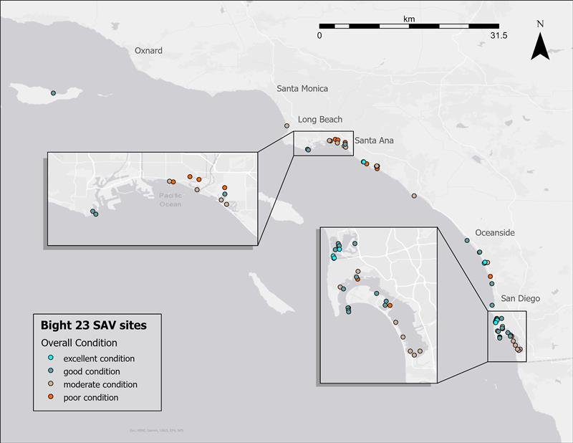Figure 5. Geographic distribution of overall eelgrass condition throughout the Southern California Bight. The legend shows point color corresponding to overall eelgrass condition categories.

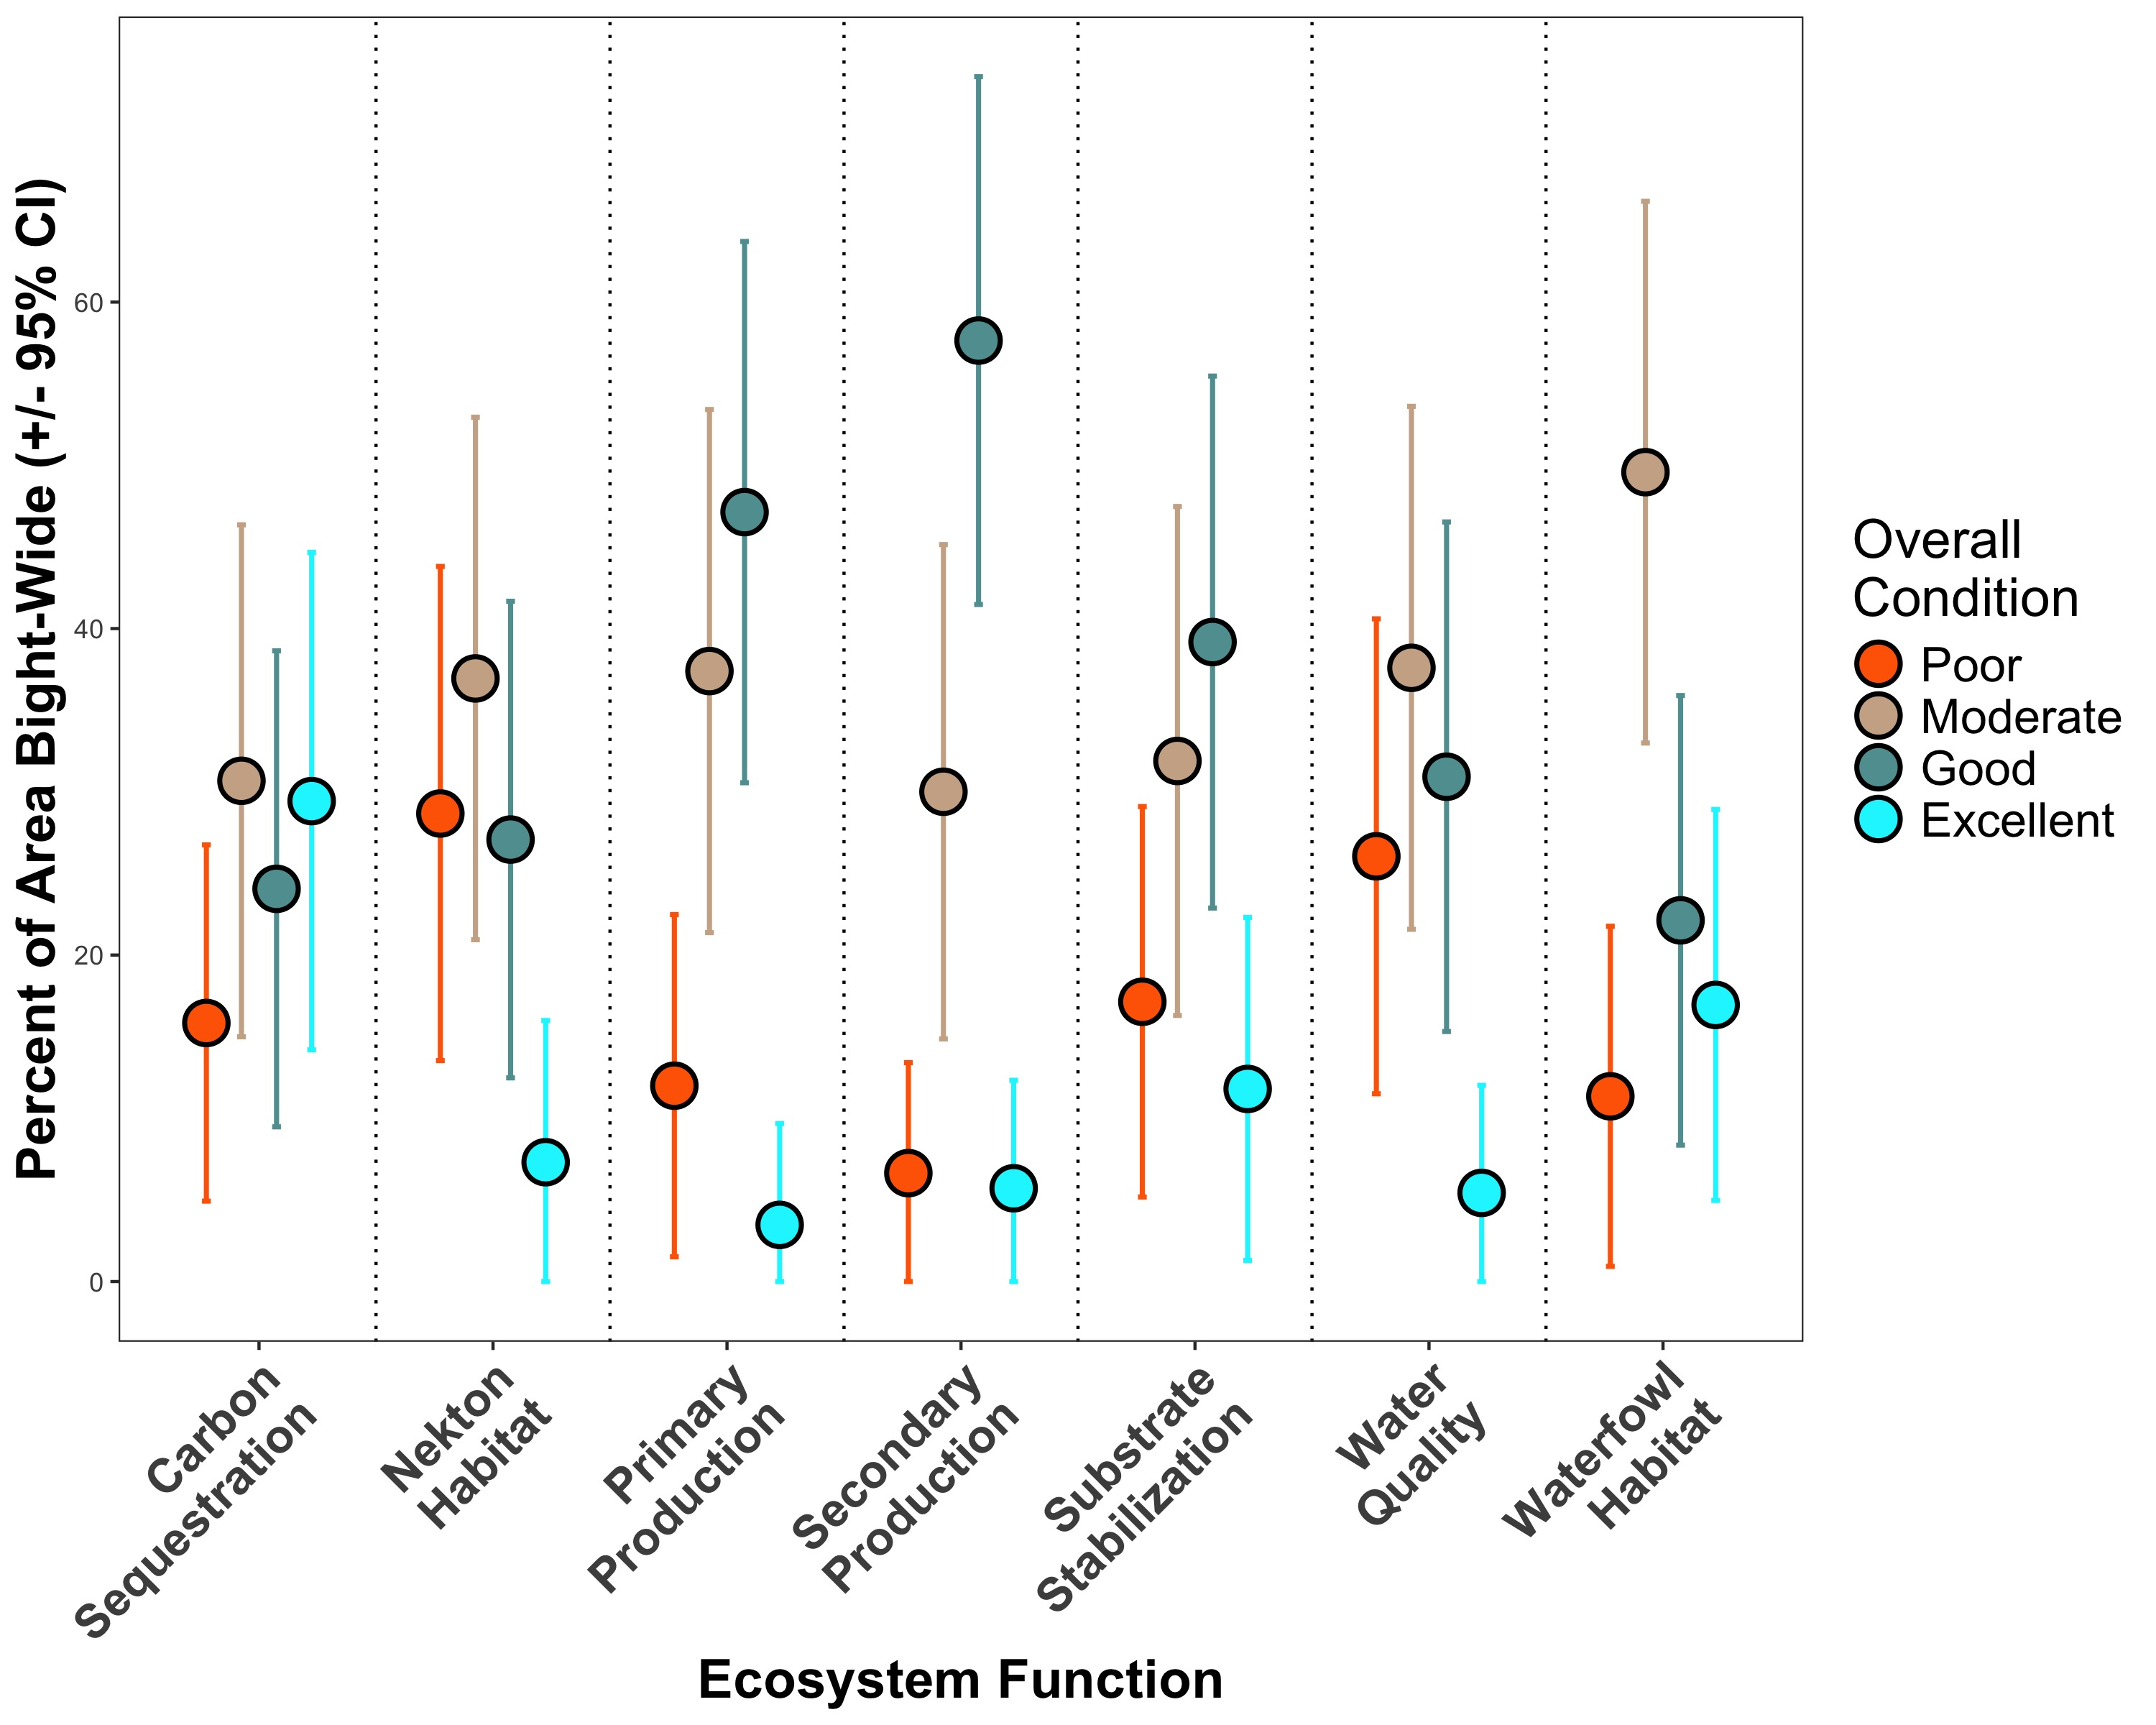
Figure 6. Percent area estimates (with 95% confidence intervals) of the seven ecosystem function scores in each of the four condition categories. Points represent area estimates, and error bars represent strata-based confidence intervals.

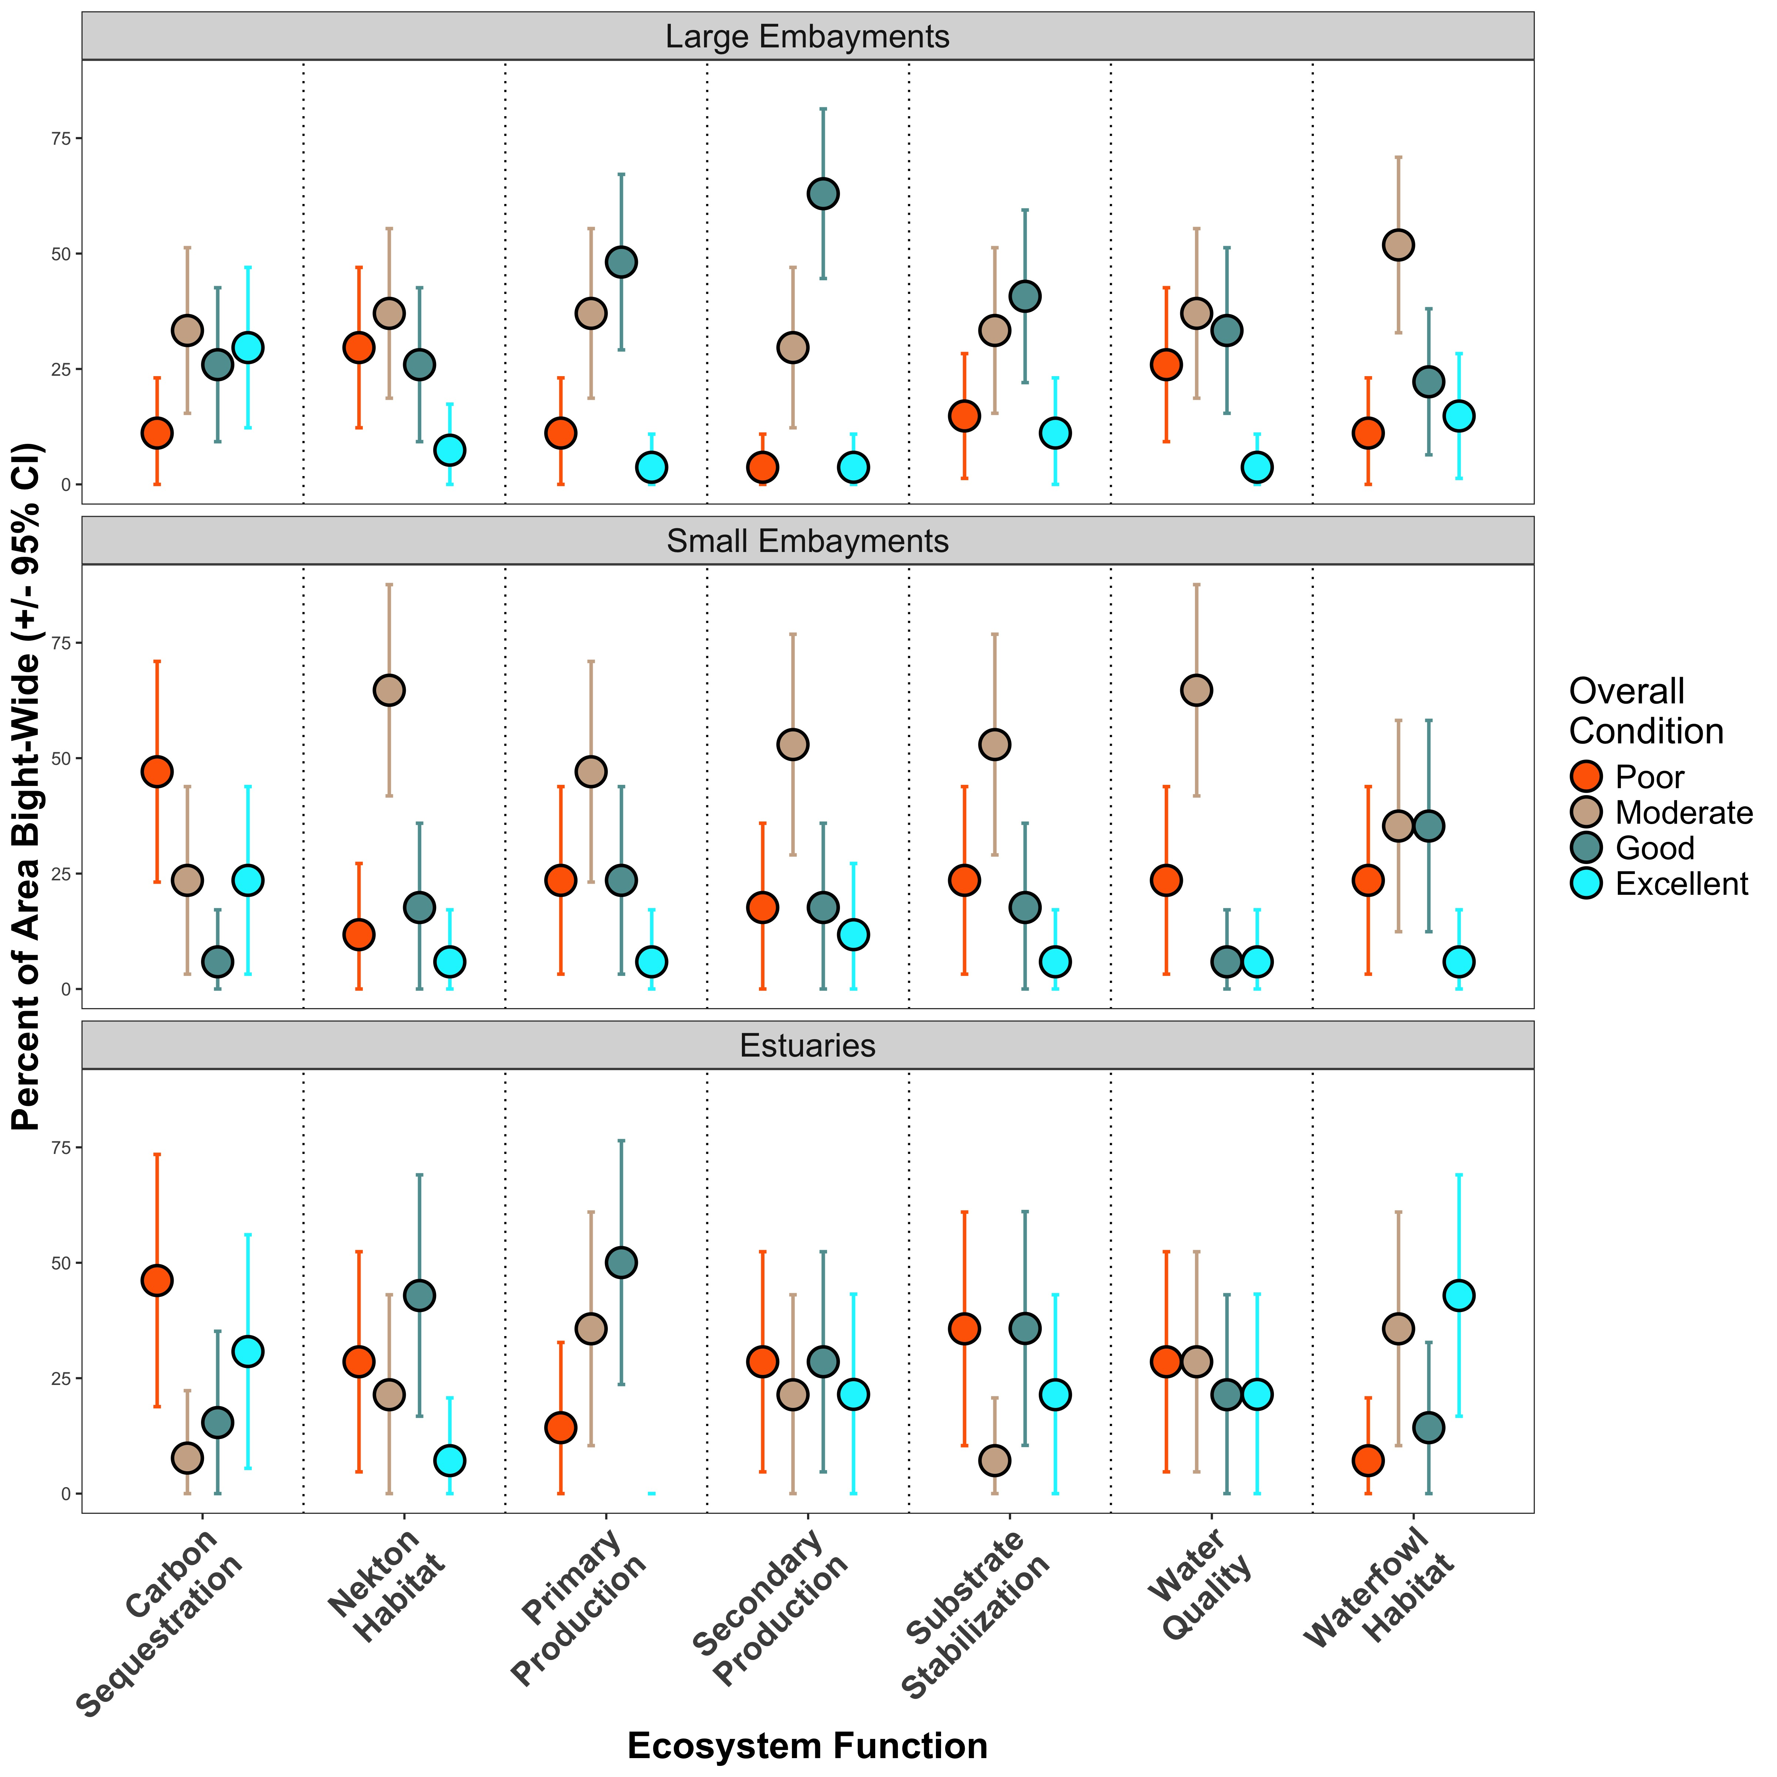
Figure 7. Percent area estimates (with 95% confidence intervals) of each of the seven ecosystem function scores in each of the four condition categories. Points represent area estimates and error bars represent strata-based confidence intervals.
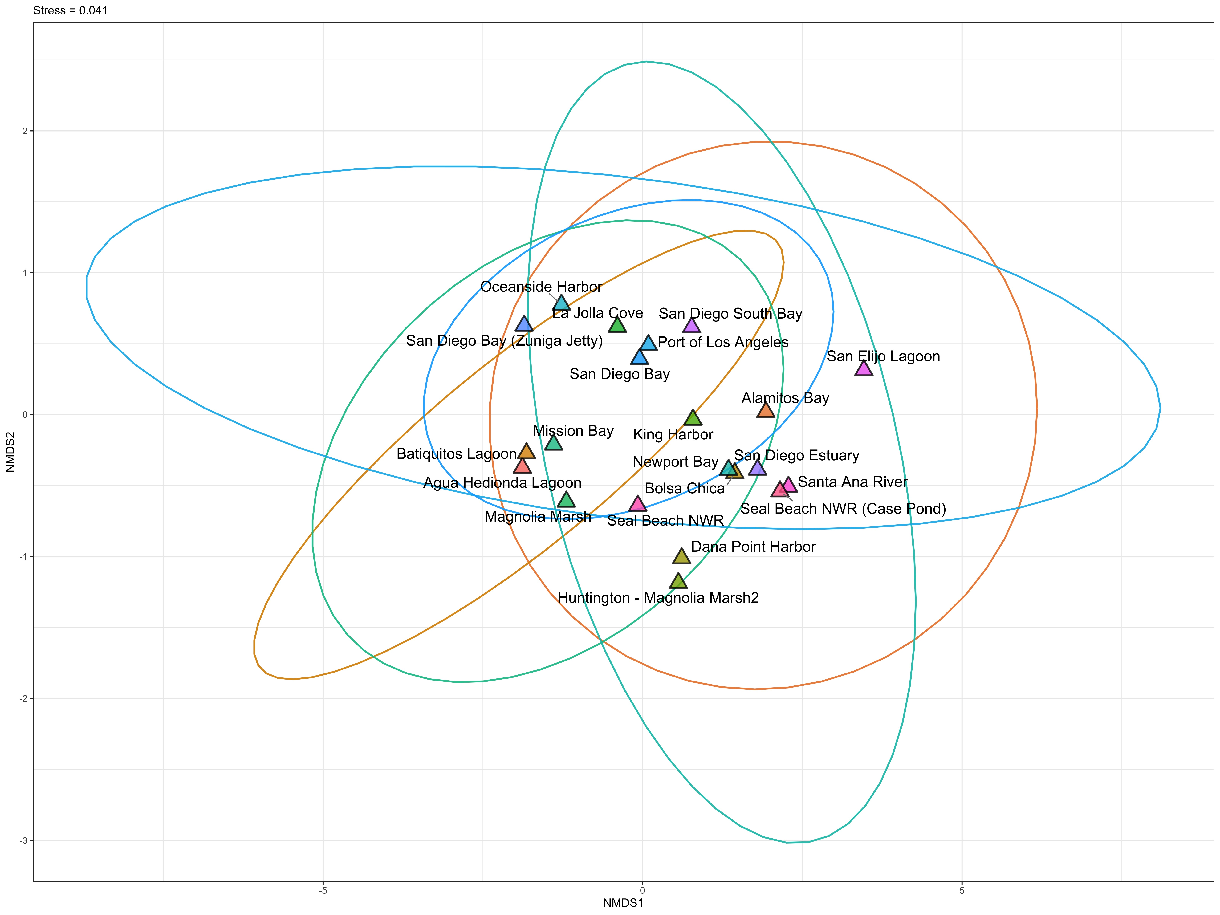
Figure 8. Non-metric multidimensional scaling plot of ecosystem function scores at each waterbody. Points represent centroids from multiple sites at each waterbody. Points and ellipses are both color-coded by waterbody. Ellipses represent 95% of the data for each waterbody. Stress = 0.041.
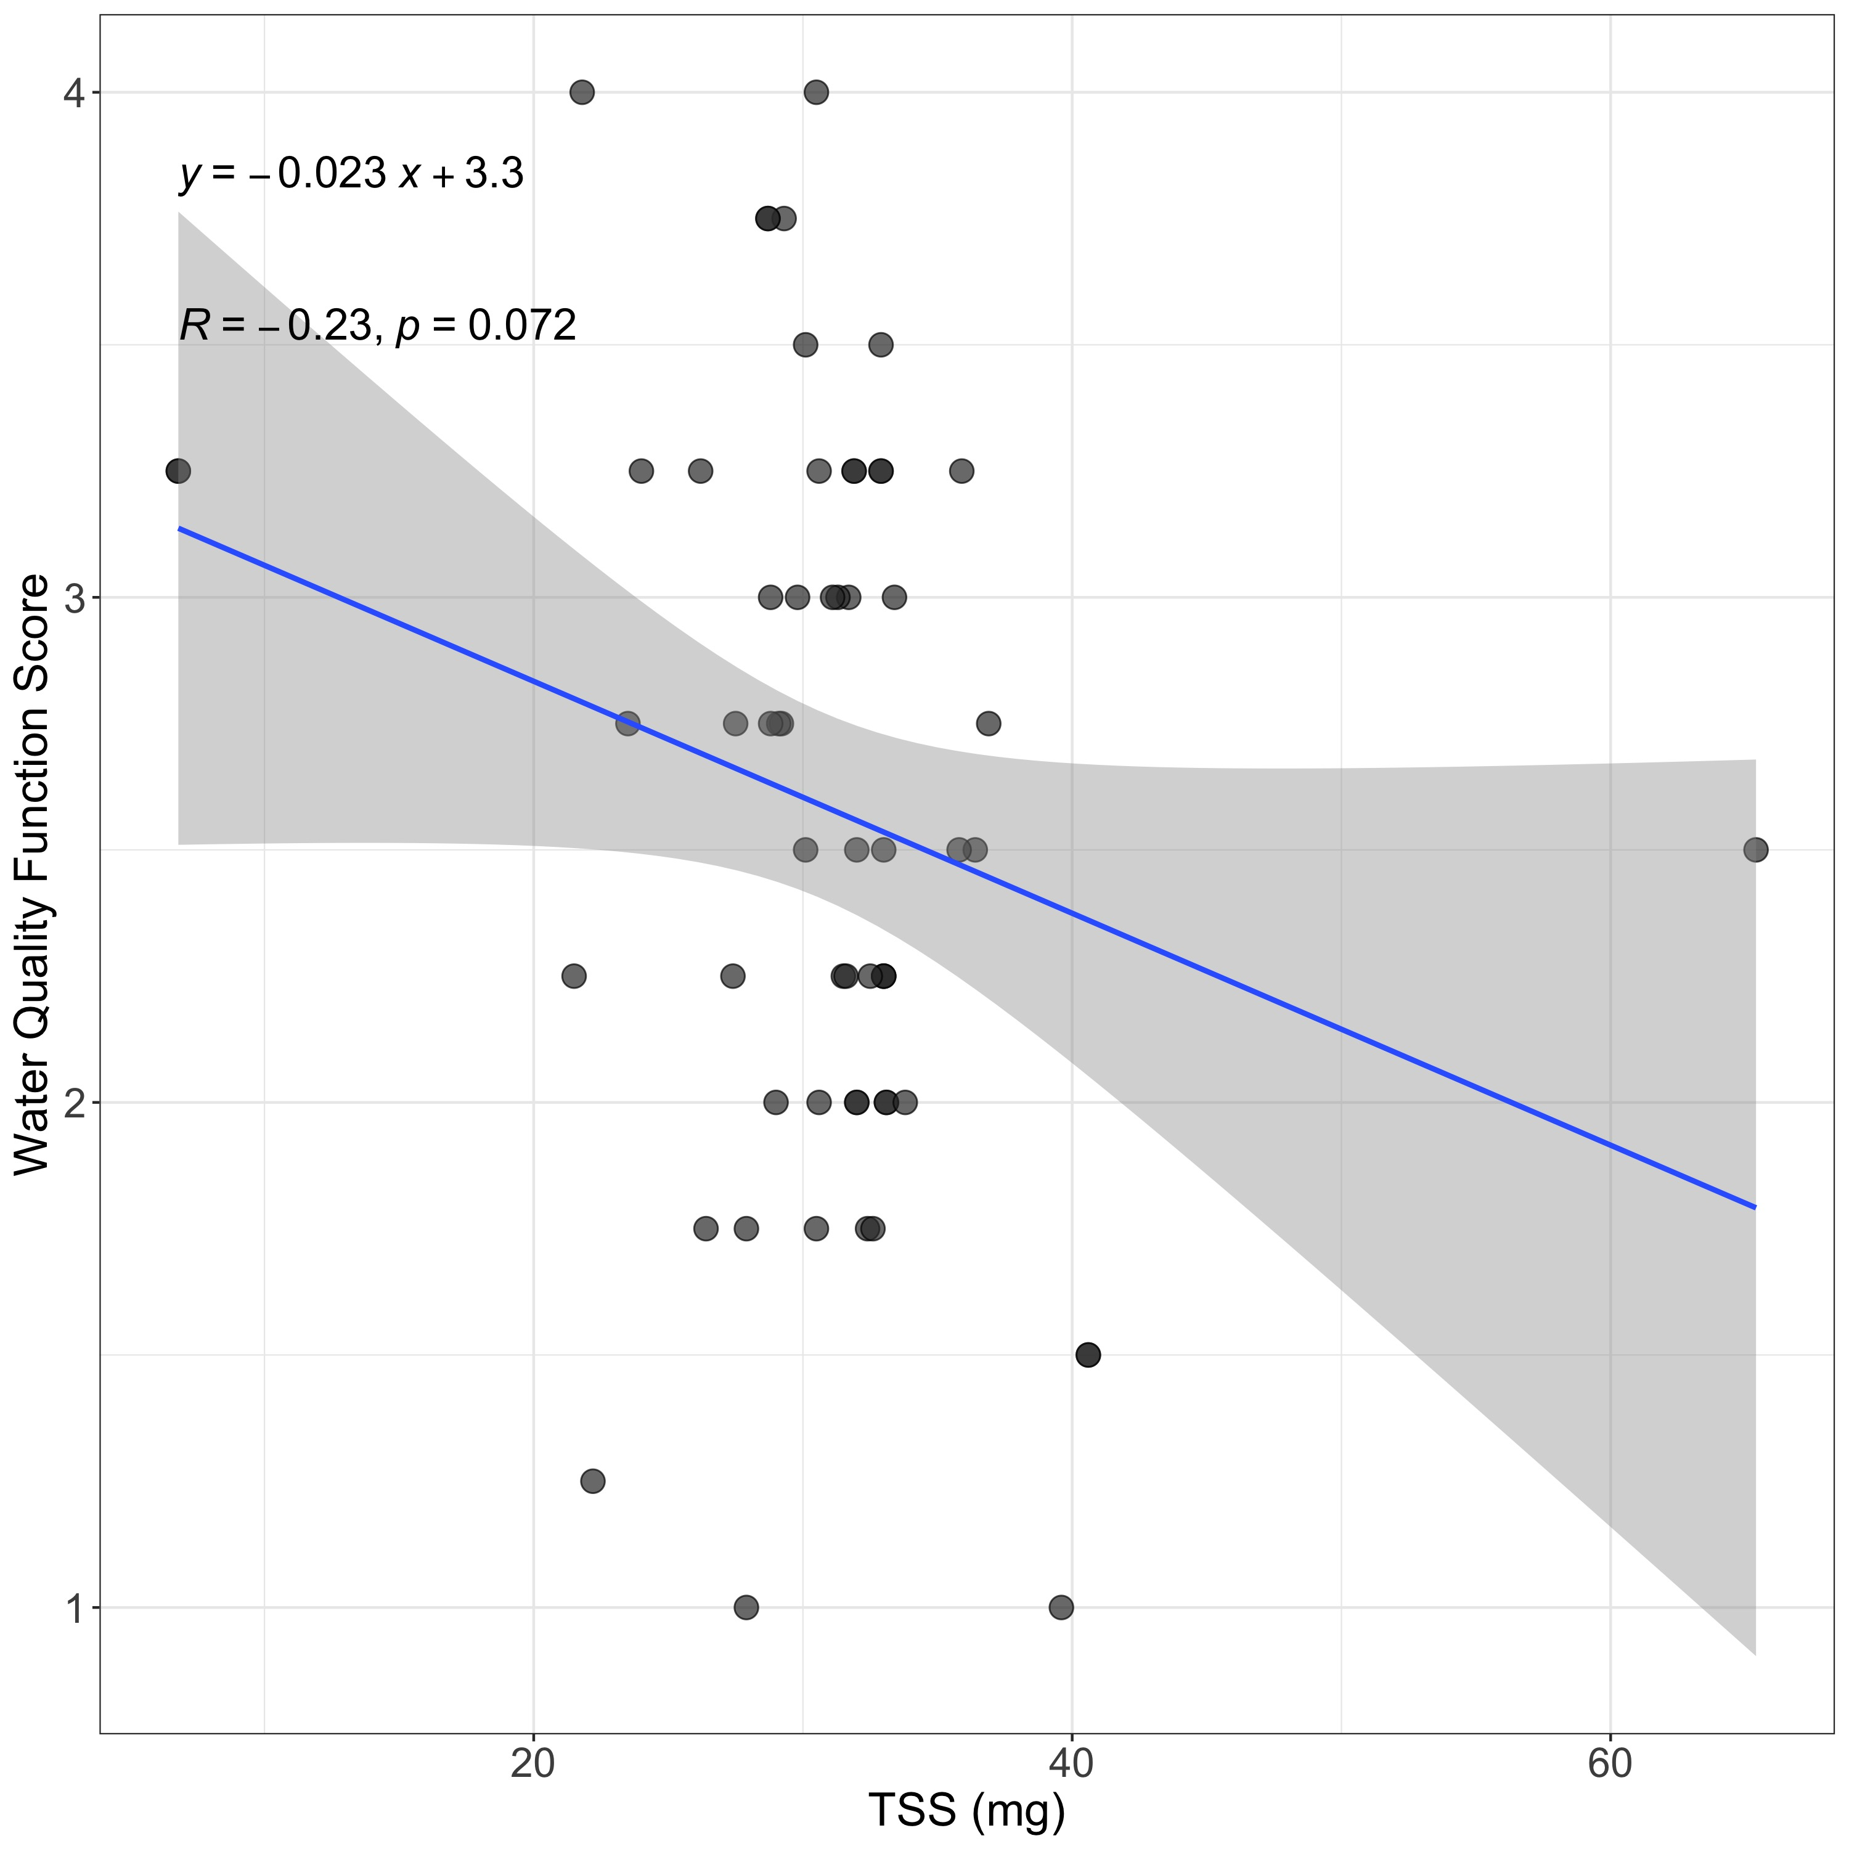
Figure 9. Total Suspended Solids (TSS) in milligrams per 500 mL water versus water quality ecosystem function scores. TSS data was not available for all sites. Geom_smooth() represents the 95% confidence interval for this observed relationship.
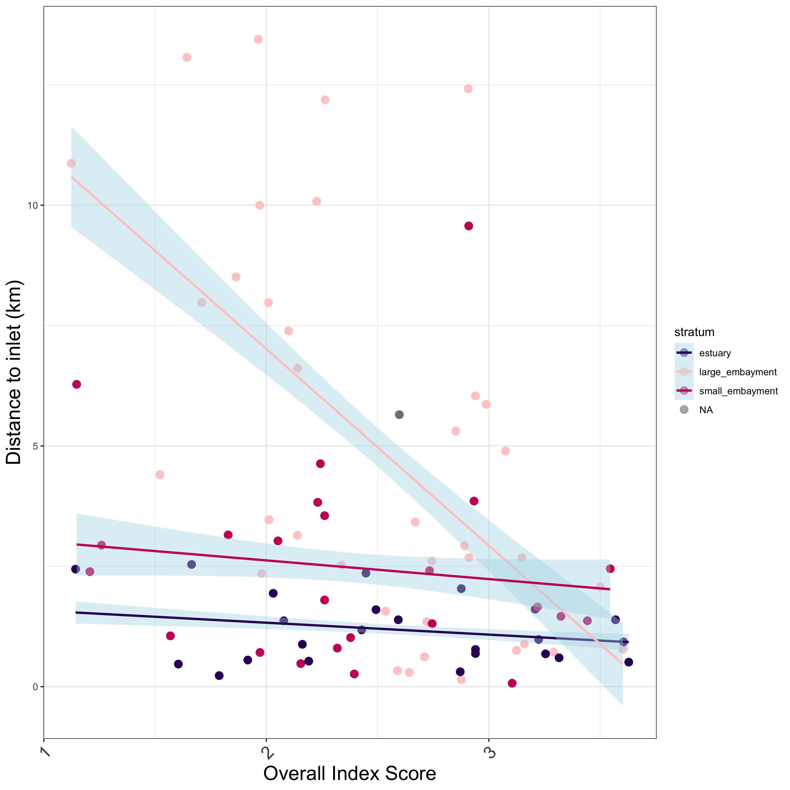
Figure 10. Overall eelgrass index scores with distance to inlet (km).
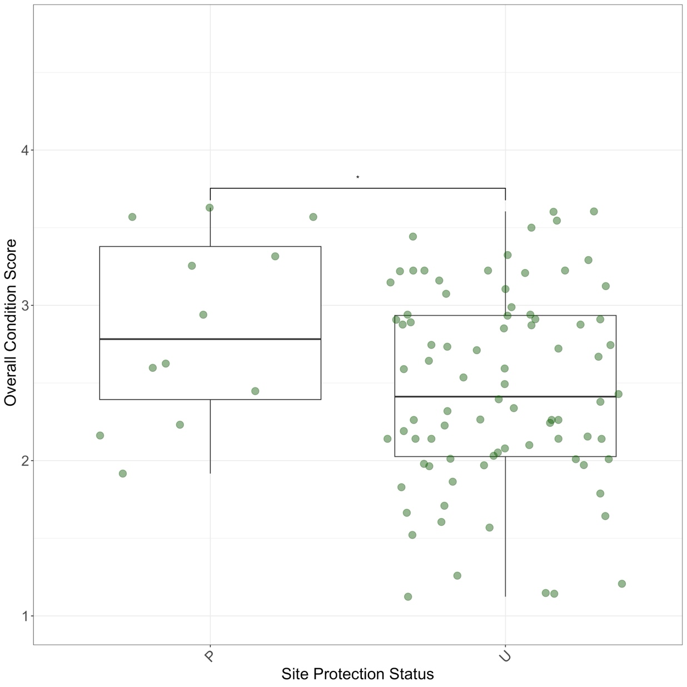
Figure 11. Overall eelgrass condition scores by nominal site protection status. P = “protected”, “U” = unprotected. Protected sites include areas within designated Marine Protected Areas (no take, limited take, State Marine Reserves, State Marine Conservation Areas). Unprotected sites are areas that are not protected from take in some way, including National Wildlife Refuges. Significant difference between groups via Wilcox test (p = 0.049).
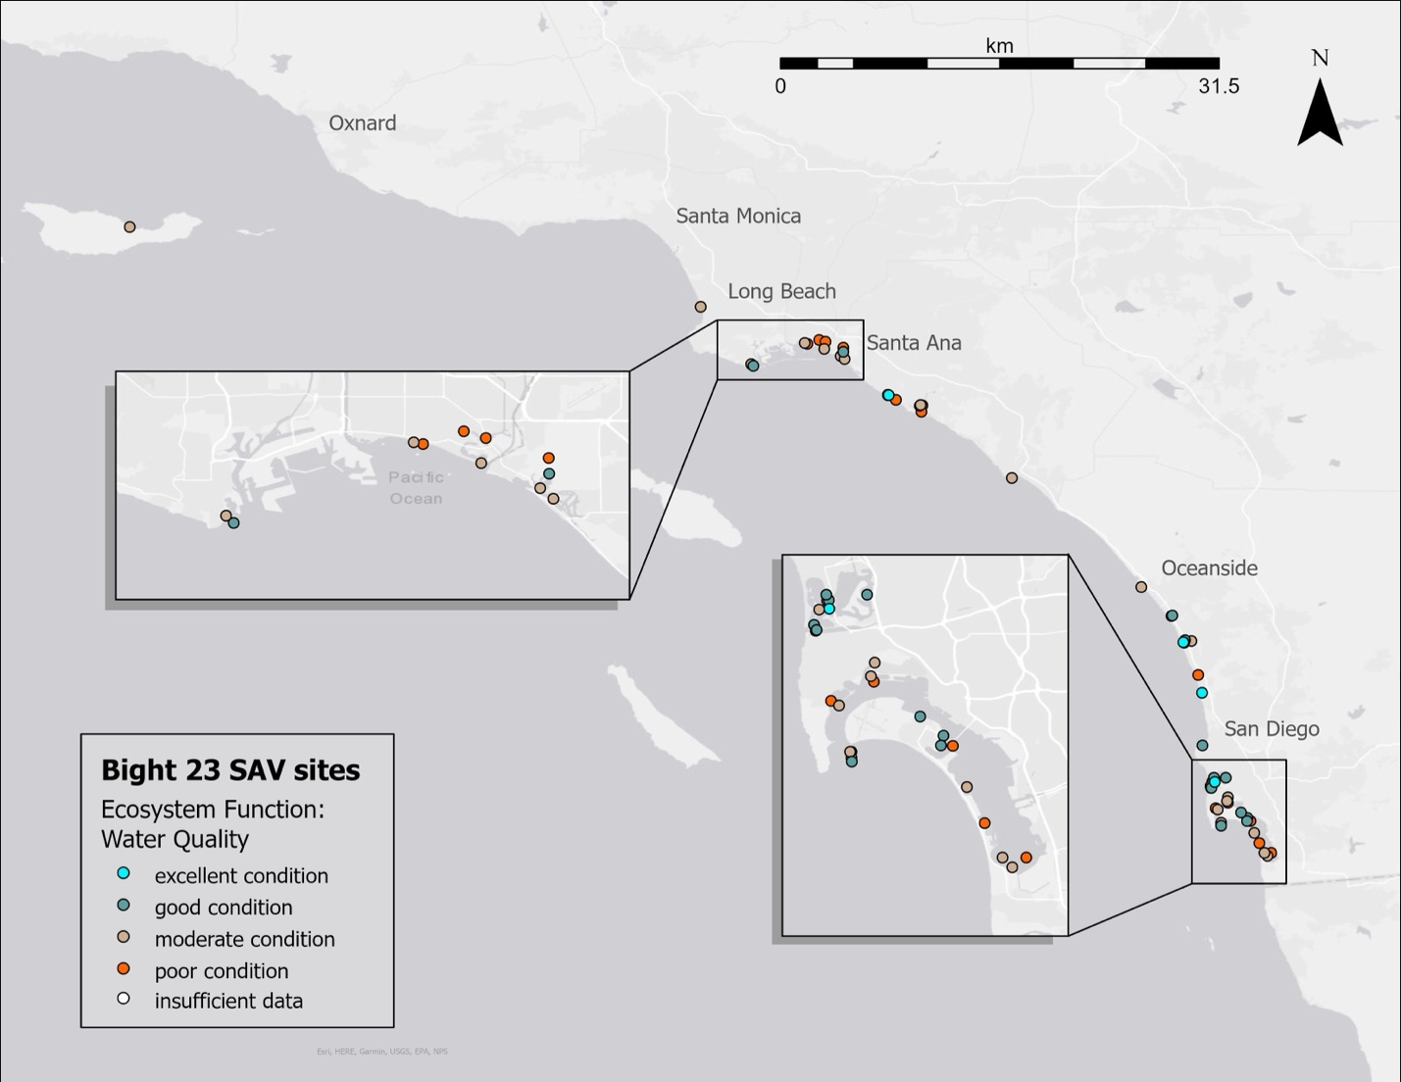
Figure 12. Geographic distribution of estimated water quality ecosystem function throughout the Southern California Bight. The legend shows point color corresponding to water quality condition categories.
- Discussion
Bight 2023 demonstrated the first regional survey of the Southern California Bight’s eelgrass beds. Two research questions motivated this regional survey of eelgrass beds: (1) what is the condition of the region’s eelgrass beds? And (2) does condition vary by stratum (large embayments, small embayments, and estuaries)? In addition to addressing these community-driven research questions, we also developed a novel, quantitative index tool for scoring eelgrass condition within the region. The development and application of this index tool was motivated by a management need to uphold the California’s Eelgrass Mitigation Policy (CEMP) directive of “…no net loss of eelgrass habitat function…” throughout the state (NOAA National Marine Fisheries Service 2014). Moreover, application and further validation of this tool may help managers holistically understand ecosystem functions provisioned by eelgrass, and therefore assess their Beneficial Uses and contributions to Essential Fish Habitat (Bernstein et al 2011).
Nearly half of the eelgrass bed area surveyed in 2024 across the Southern California Bight was in Good Condition, followed by nearly a third of the remaining eelgrass bed area in Moderate Condition. Due to the probabilistic sampling design of this survey, we extend this assessment beyond the surveyed area, to estimate the condition across the region. Furthermore, there were estimated differences in overall eelgrass condition across strata. Within our spatially-explicit design, whereby an equal number of sites were chosen from each stratum, we extend the observation that the majority of eelgrass bed area in small embayments are in Moderate Condition, whereas the highest percentage of area in estuaries and large embayments are in Good Condition. All ports and harbors (Port of Los Angeles, King Harbor, Oceanside Harbor, Dana Point Harbor) were considered small embayments, which may account for the observed contrast in overall eelgrass condition. Ports and harbors may be influenced more acutely by boating activity, wave exposure, pollution, and human recreation than other waterbody types, which can all be deleterious to eelgrass condition (Fonseca & Bell 1998, Hansen & Reidenbach 2012). Eelgrass in these settings may also be susceptible to potential stressors due to their proximity to the densely populated Southern California coastline (CITATION). For example, one site in the Port of Los Angeles (B23-SAV-015) had 65.4 mg/L TSS, which was the highest TSS value Bight-wide. Sedimentation of the water column in a known stressor to eelgrass, limiting light available to the plant itself, and can be exacerbated by human activities such as boating.
Among the utilities of the eelgrass index is the ability to deconstruct the tool into its corresponding ecosystem functions, and even the structural metrics included in the calculation of those functions, to investigate how unexpectedly low or high scores arise. For example, potential explanations for the discrepancy observed in overall eelgrass condition between small embayments and other two strata can be investigated in this way. In small embayments, Carbon Sequestration had the largest amount of area in Poor Condition, with most area in the other six ecosystem functions estimated in Moderate Condition. Aboveground and Belowground biomass were averaged to produce the Carbon Sequestration ecosystem function score, and in the case of small embayments, belowground biomass was slightly (though not statistically significantly) less than in large embayments (Figure A2). Estuaries showed the same pattern of estimated Carbon Sequestration in Poor Condition. If a manager was interested in boosting Carbon Sequestration ecosystem function estimated by this tool, and therefore overall eelgrass condition, creating environmental settings that facilitate belowground storage of carbon in eelgrass could be a starting point.
On the other hand, a manager could also use this same approach to investigate the patterns in high scoring sites. For example, estuaries had their largest area estimated in Excellent Condition for Waterfowl Habitat. This observation is supported by a large body of estuarine literature, as well as a growing repository of citizen science data, emphasizing the importance of estuaries as bird habitat (CITATIONS). Sites with long shoot heights and large shoot densities receive high Waterfowl Habitat ecosystem function scores. While shoot height was comparable across strata, shoot density was higher (though not statistically significantly) in estuaries than in the other two strata (Figure A1). The reason for high Waterfowl Habitat scores based on this tool comes down to estuaries having the right conditions for dense beds of eelgrass. The investigation of high scoring sites presents the opportunity to validate this novel eelgrass index by drawing direct comparisons between shoot density, Waterfowl Habitat ecosystem function scores, and bird activities (foraging, mating, migration). Leveraging available and concurrent estuary data from California monitoring programs such as EMPA (EMPA webpage), and connecting it with eelgrass data presented here, could be a starting point for eelgrass index validation around Waterfowl Habitat, Water Quality, Nekton Habitat, and Secondary Production ecosystem functions (O’Connor et al 2025).
A useful index from the standpoint of measuring habitat function loss in eelgrass is one that is responsive to eelgrass stressors (pollution, light limitation, disease, destructive activities), but is not sensitive to natural gradients (depth) (CITATION). However, some relationships between index scores and predictor variables (eutrophication, protection status, distance to inlet) are expected to be more complex. For example, water column chlorophyll a and TSS can both be indicators of eutrophication, which can harm eelgrass through macroalgal overgrowth and light limitation (negative), but may also facilitate growth of eelgrass itself (positive). The dual nature of these indicators on both the environmental setting as well as the plant allow understanding of how this index responds to a complex environment, but is not a complete evaluation of index performance. Likewise, distance to inlet may be an indirect measurement of pollution and environmental stability, with beds closest to the inlet further from sources of pollution and under stable marine influence, which could signify low stress conditions for eelgrass (CITATION). There is a negative relationship between index scores and distance to inlet, with increasing distance to inlet (further inland sites) scoring lower than sites close to the inlet in large embayments only. No such relationship was observed in either estuary nor small embayment strata. This is likely due to the smaller size of waterbodies the latter two strata, with distance to inlet capped well below 10 km in all cases (Citation?). More information regarding complex estuarine chemistry and circulation is needed to tease out the relationship between site location within a body of water and its condition. Site protection status may also have a complex relationship with eelgrass health. Certain protections of a site within a Marine Protected Area may facilitate better eelgrass condition by creating conditions that reduce ecological impact from human activities (CITATION). On the other hand, locations of Marine Protected Areas are chosen based on many different criteria and objectives from a diverse community of interested parties (Gleason et al 2013). Protections may be enacted to conserve an already ecologically healthy area, or they could be put in place to help an impacted area recover. The relationship between protection status and eelgrass index score may be partially explained by protections facilitating healthy eelgrass condition, but it also could be equally explained by management selection of already healthy sites. Even so, there was a significant difference in eelgrass index scores between protected and unprotected sites, with higher scores estimated at protected sites. While there is not a clear reason for this observation, the responsiveness of the eelgrass index to site protection status indicates a level of effectiveness for management use.
The results from this study are the first practical application (concurrent with the RESCQ study) of the conceptual model proposed by McCune et al. 2020, and characterize the overall condition of eelgrass throughout the Southern California Bight. This tool is uniquely positioned to allow management and regulatory communities to better understand eelgrass condition from the perspective of supported ecosystem functions. Due to the ephemeral spatial coverage of eelgrass over time, as reported by several previous inventories (Merkel & Associates Inc. 2014b; Merkel & Associates Inc. 2024), structural eelgrass data through a longer time period is recommended to refine the existing tool, as data from only one season (late summer/fall 2024) was used to develop the tool. The monitoring approach and framework underpinning the index tool should translate to other regions, regardless of the dominant seagrass species. In some cases, implementation in other habitats may benefit from a revision of the conceptual model, to ensure that all ecosystem functions are supported by the species of interest. For example, some smaller species may not have as comparable ecosystem functions as larger species (Nordlund et al. 2016). However, the existing index here is generated using a range of structural metrics measured in Southern California, and should therefore be used with caution in other locations that have different species or environmental conditions. For example, The North Pacific US Coast, while dominated by Zostera marina, has a larger proportion of intertidal eelgrass than in Southern California, which may impact its morphology and therefore structural metrics such as shoot height, leaf area, above and belowground biomass (Sherman & DeBruyckere 2018). Additionally, other environmental changes that occur across a latitudinal gradient (water and air temperature, PAR, exposure, coastal morphology) may also impact the morphology of the seagrass through phenotypic plasticity of the plant itself (CITATION). Applying this index framework to other locations with different species of seagrass appropriately requires adjustment of structural metrics to the species or group of species present.

- Conclusions
- Most of the Bight-wide area of eelgrass is in either Good or Moderate Condition
- Estuaries and large embayments have slightly better overall eelgrass condition than small embayments
- We have developed a novel, quantitative tool to score Zostera marina condition through the perspective of supported ecosystem functions across the Southern California Bight
- Several environmental features helped us understand how eelgrass scores and estimated ecosystem functions relate to areas with complex coastal chemistry, protection, and circulation.

- Recommendations
- Literature Cited
Bernstein B, Merkel K, Chesney B, Sutula M (2011) Recommendations for a Southern California Regional Eelgrass Monitoring Program - SCCWRP Technical Report 632. Costa Mesa, CA.
Mary Gleason, Evan Fox, Susan Ashcraft, Jason Vasques, Elizabeth Whiteman, Paulo Serpa, Emily Saarman, Meg Caldwell, Adam Frimodig, Melissa Miller-Henson, John Kirlin, Becky Ota, Elizabeth Pope, Mike Weber, Ken Wiseman (
Designing a network of marine protected areas in California: Achievements, costs, lessons learned, and challenges ahead,
Ocean & Coastal Management,
Volume 74,
2013,
Pages 90-101,
ISSN 0964-5691,
Merkel & Associates Inc. (2014a) 2014 San Diego Bay Eelgrass Inventory.
Merkel & Associates Inc. (2024) 2023 San Diego Bay Eelgrass Inventory Update. San Diego, CA.
Merkel & Associates Inc. (2014b) Southern California Bight Regional Eelgrass Surveys. NOAA/ National Marine Fisheries Service West Coast Region Protected Resources Division, San Diego, CA.
NOAA National Marine Fisheries Service (2014) California Eelgrass Mitigation Policy and Implementing Guidelines.
O’Connor K, Fulkerson B, Walker J, Stein E, Whitcraft CR, Huckeba J (2025) Estuary Marine Protected Area Fall 2023 Data Analysis Report SCCWRP Technical Report #1430. Costa Mesa, CA.
Appendix A – Eelgrass structural metrics

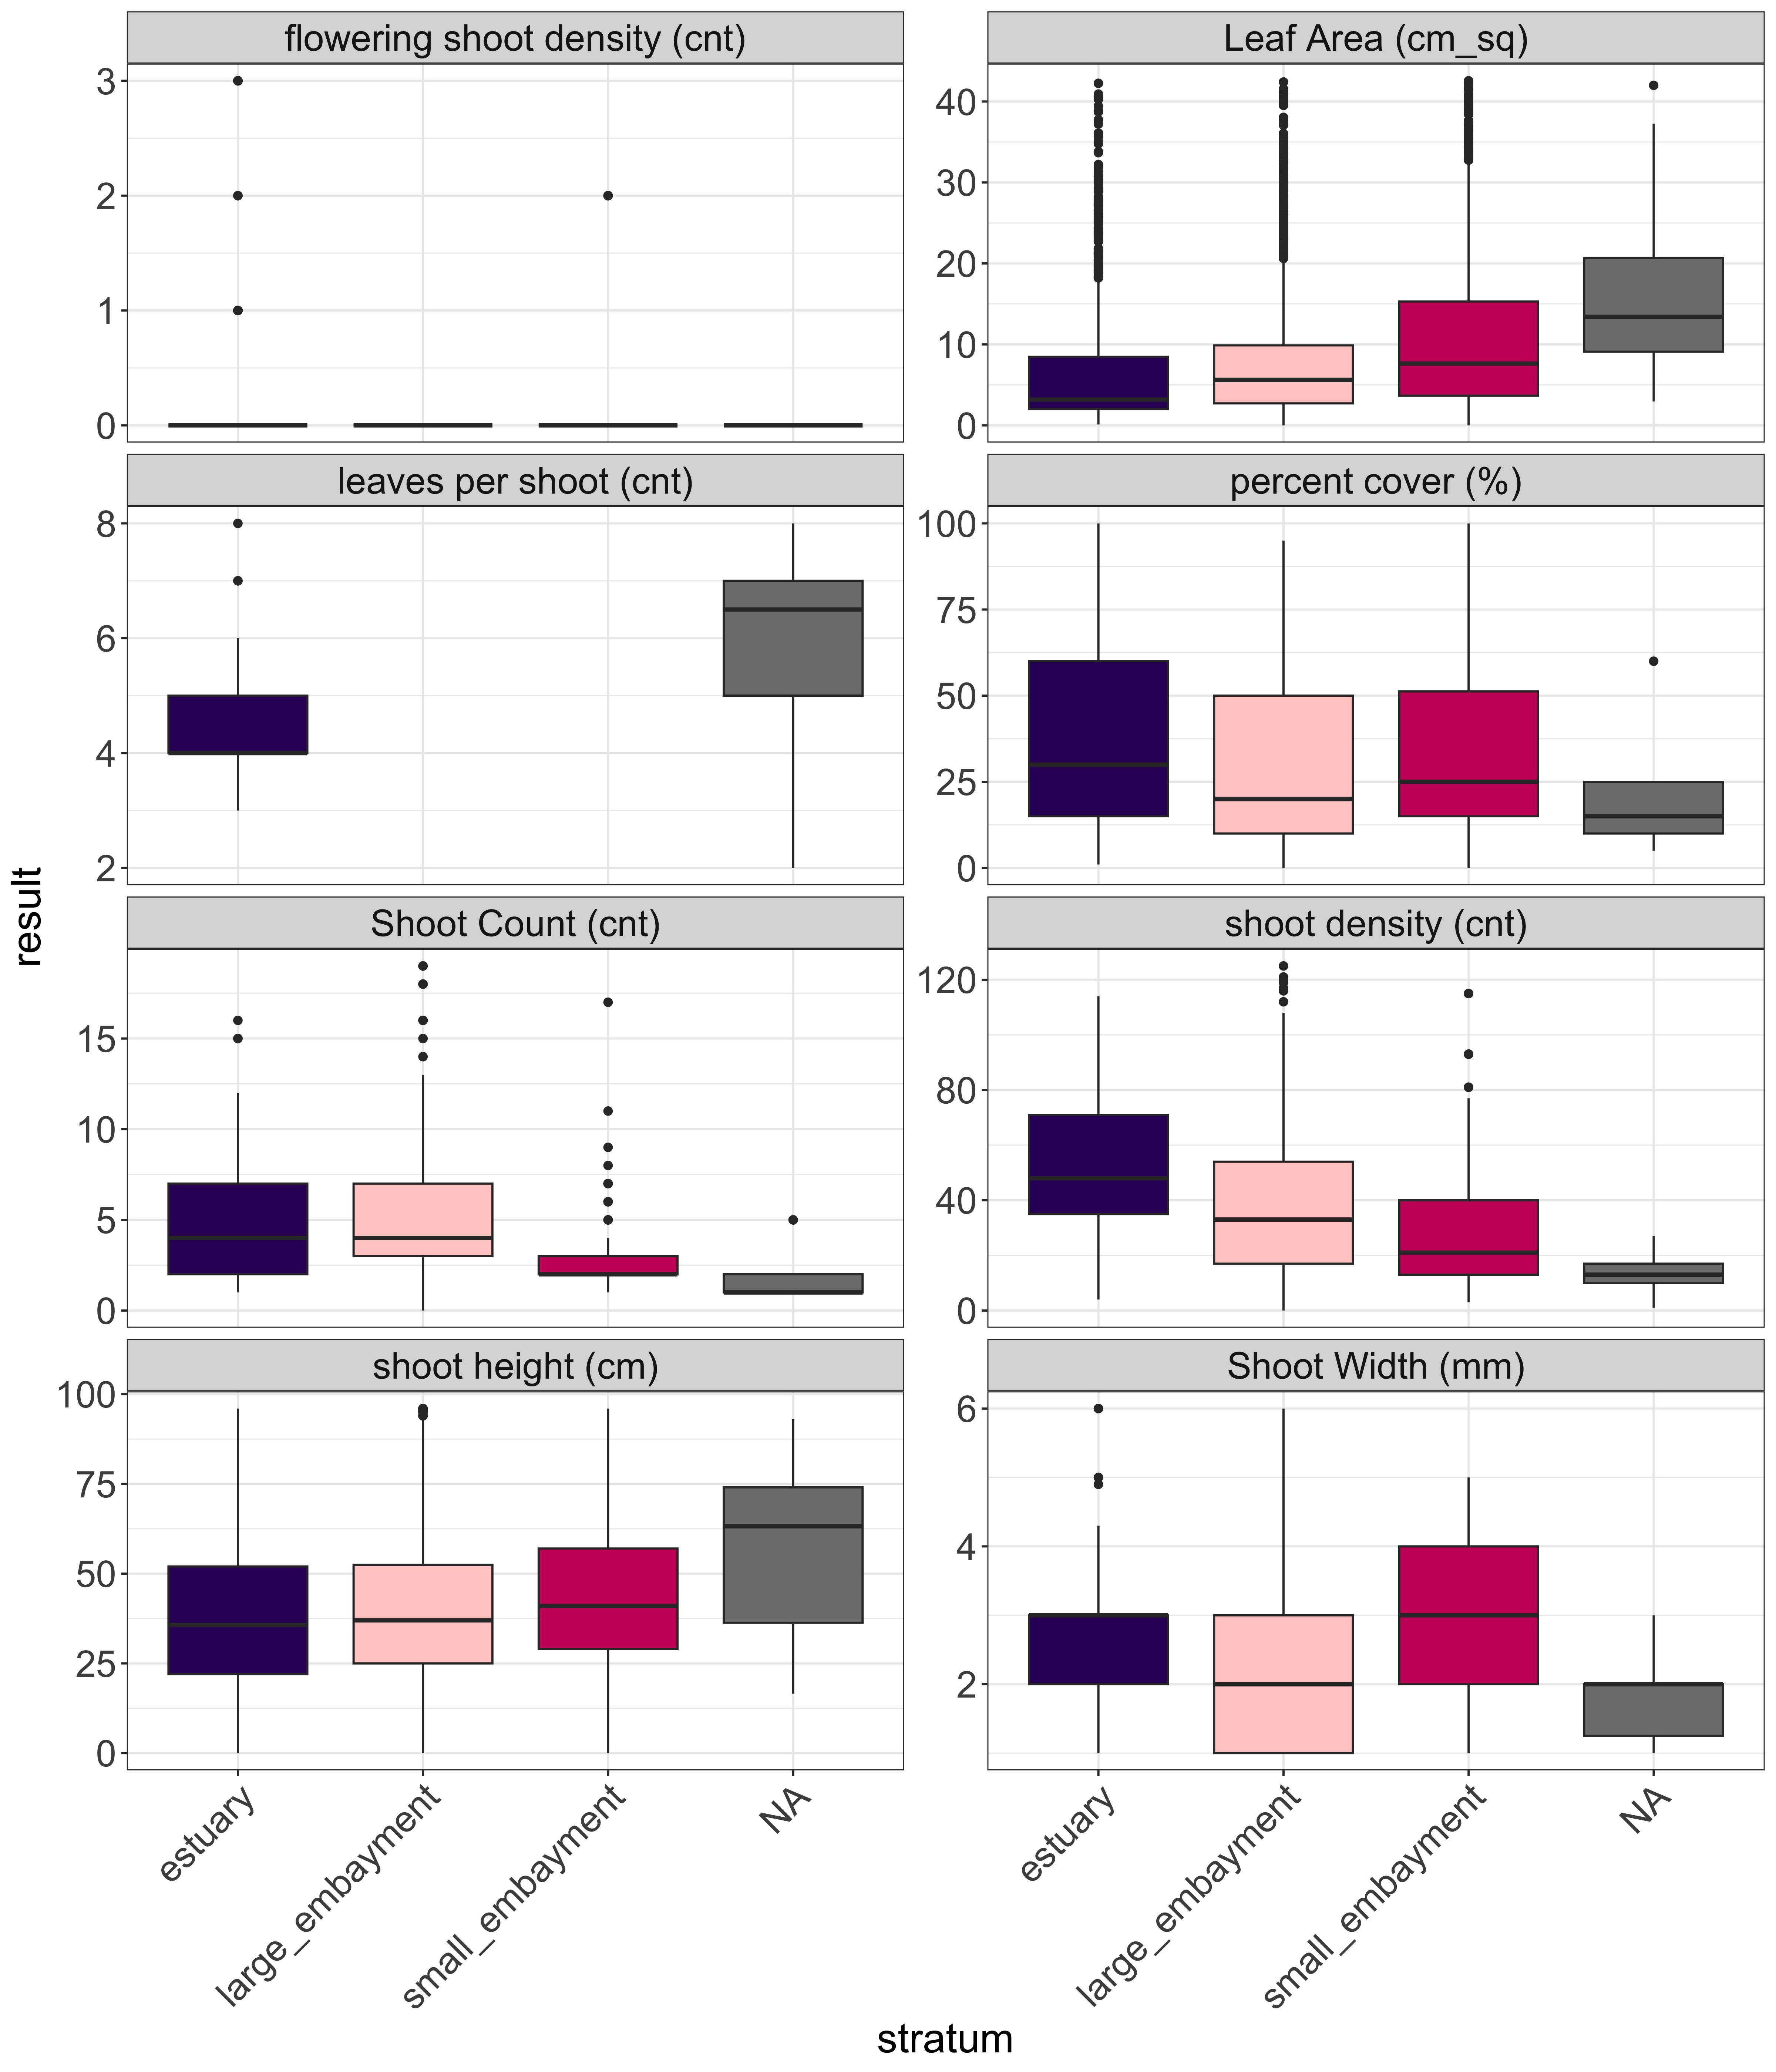
Figure A1. Eelgrass structural metric data by stratum – part 1.
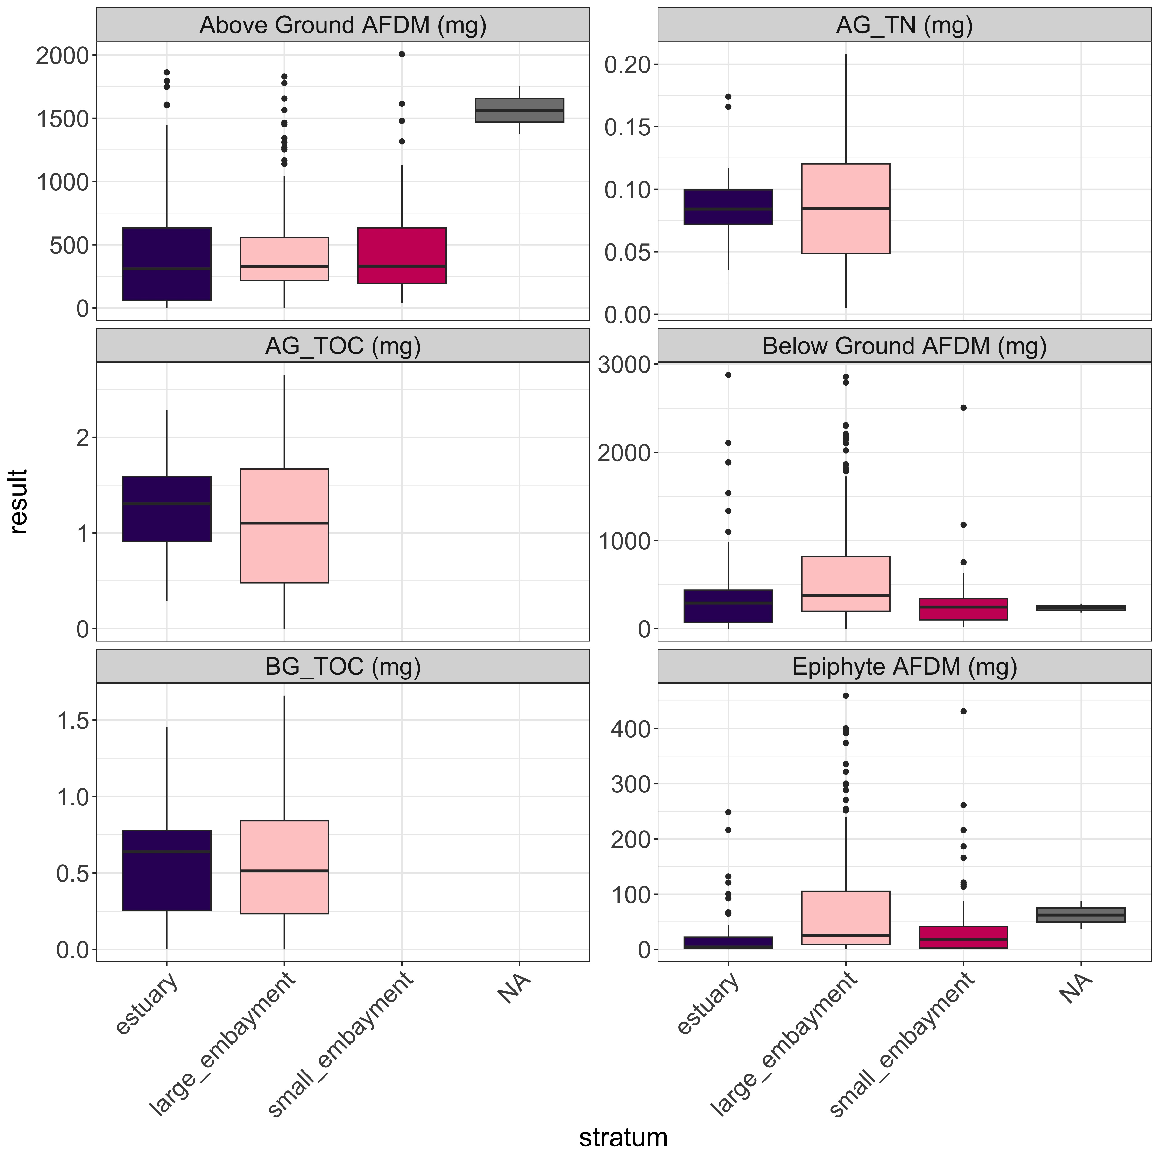
Figure A2. Eelgrass structural metric data by stratum – part 2.

Appendix B – Eelgrass index and function scores

Table B1. Site by site ecosystem function scores and overall eelgrass condition scores.
Table B2. Overall eelgrass condition scores by waterbody
waterbody | mean | sd | min | max | range | Overall condition
Agua Hedionda Lagoon | 3.082 | 0.147 | 2.94 | 3.22 | 0.28 | good condition
Alamitos Bay | 1.731 | 0.412 | 1.21 | 2.32 | 1.11 | poor condition
Batiquitos Lagoon | 2.989 | 0.35 | 2.45 | 3.32 | 0.87 | good condition
Bolsa Chica | 1.917 | 0 | 1.92 | 1.92 | 0 | moderate condition
Dana Point Harbor | 2.243 | 0 | 2.24 | 2.24 | 0 | moderate condition
Huntington - Magnolia Marsh | 2.262 | 0 | 2.26 | 2.26 | 0 | moderate condition
King Harbor | 2.155 | 0 | 2.15 | 2.15 | 0 | moderate condition
La Jolla Cove | 2.598 | 0 | 2.6 | 2.6 | 0 | good condition
Magnolia Marsh | 2.904 | 0.666 | 2.26 | 3.55 | 1.29 | good condition
Mission Bay | 2.96 | 0.51 | 1.98 | 3.6 | 1.62 | good condition
Newport Bay | 1.944 | 0.266 | 1.52 | 2.23 | 0.71 | moderate condition
Oceanside Harbor | 2.91 | 0 | 2.91 | 2.91 | 0 | good condition
Port of Los Angeles | 2.395 | 0.78 | 1.15 | 3.1 | 1.95 | moderate condition
San Diego Bay | 2.462 | 0.48 | 1.64 | 3.07 | 1.43 | moderate condition
San Diego Bay (Zuniga Jetty) | 3.124 | 0 | 3.12 | 3.12 | 0 | good condition
San Diego Estuary | 1.788 | 0 | 1.79 | 1.79 | 0 | moderate condition
San Diego South Bay | 2.138 | 0.107 | 2.01 | 2.26 | 0.25 | moderate condition
San Dieguito Lagoon | 3.208 | 0 | 3.21 | 3.21 | 0 | good condition
San Elijo Lagoon | 1.143 | 0 | 1.14 | 1.14 | 0 | poor condition
Santa Ana River | 1.605 | 0 | 1.6 | 1.6 | 0 | poor condition
Santa Cruz Island | 2.625 | 0 | 2.62 | 2.62 | 0 | good condition
Seal Beach NWR | 2.477 | 0.414 | 2.08 | 2.88 | 0.8 | moderate condition
Seal Beach NWR (Case Pond) | 1.664 | 0 | 1.66 | 1.66 | 0 | poor condition

Table B3. Percent area-weighted ecosystem function scores by stratum, including upper and lower 95% confidence intervals.
Ecosystem Function | Stratum | Condition | Percent Area Estimate | Lower 95% CI | Upper 95% CI
substrate stabilization | estuary | Poor | 35.69 | 10.39 | 60.98
substrate stabilization | estuary | Moderate | 7.14 | 0 | 20.73
substrate stabilization | estuary | Good | 35.76 | 10.44 | 61.08
substrate stabilization | estuary | Excellent | 21.41 | 0 | 43.07
substrate stabilization | estuary | Total | 100 | 100 | 100
substrate stabilization | large_embayment | Poor | 14.81 | 1.3 | 28.33
substrate stabilization | large_embayment | Moderate | 33.33 | 15.4 | 51.27
substrate stabilization | large_embayment | Good | 40.74 | 22.05 | 59.43
substrate stabilization | large_embayment | Excellent | 11.11 | 0 | 23.07
substrate stabilization | large_embayment | Total | 100 | 100 | 100
substrate stabilization | small_embayment | Poor | 23.53 | 3.22 | 43.84
substrate stabilization | small_embayment | Moderate | 52.94 | 29.04 | 76.84
substrate stabilization | small_embayment | Good | 17.65 | 0 | 35.9
substrate stabilization | small_embayment | Excellent | 5.88 | 0 | 17.15
substrate stabilization | small_embayment | Total | 100 | 100 | 100
carbon sequestration | estuary | Poor | 46.15 | 18.83 | 73.48
carbon sequestration | estuary | Moderate | 7.69 | 0 | 22.3
carbon sequestration | estuary | Good | 15.38 | 0 | 35.16
carbon sequestration | estuary | Excellent | 30.77 | 5.47 | 56.07
carbon sequestration | estuary | Total | 100 | 100 | 100
carbon sequestration | large_embayment | Poor | 11.11 | 0 | 23.07
carbon sequestration | large_embayment | Moderate | 33.33 | 15.4 | 51.27
carbon sequestration | large_embayment | Good | 25.93 | 9.25 | 42.6
carbon sequestration | large_embayment | Excellent | 29.63 | 12.25 | 47
carbon sequestration | large_embayment | Total | 100 | 100 | 100
carbon sequestration | small_embayment | Poor | 47.06 | 23.15 | 70.96
carbon sequestration | small_embayment | Moderate | 23.53 | 3.21 | 43.85
carbon sequestration | small_embayment | Good | 5.88 | 0 | 17.15
carbon sequestration | small_embayment | Excellent | 23.53 | 3.21 | 43.85
carbon sequestration | small_embayment | Total | 100 | 100 | 100
primary production | estuary | Poor | 14.27 | 0 | 32.74
primary production | estuary | Moderate | 35.69 | 10.39 | 60.98
primary production | estuary | Good | 50.04 | 23.63 | 76.44
primary production | estuary | Excellent | 0 | 0 | 0
primary production | estuary | Total | 100 | 100 | 100
primary production | large_embayment | Poor | 11.11 | 0 | 23.07
primary production | large_embayment | Moderate | 37.04 | 18.67 | 55.41
primary production | large_embayment | Good | 48.15 | 29.14 | 67.16
primary production | large_embayment | Excellent | 3.7 | 0 | 10.89
primary production | large_embayment | Total | 100 | 100 | 100
primary production | small_embayment | Poor | 23.53 | 3.22 | 43.84
primary production | small_embayment | Moderate | 47.06 | 23.16 | 70.96
primary production | small_embayment | Good | 23.53 | 3.22 | 43.84
primary production | small_embayment | Excellent | 5.88 | 0 | 17.15
primary production | small_embayment | Total | 100 | 100 | 100
secondary production | estuary | Poor | 28.55 | 4.7 | 52.4
secondary production | estuary | Moderate | 21.41 | 0 | 43.07
secondary production | estuary | Good | 28.55 | 4.7 | 52.4
secondary production | estuary | Excellent | 21.49 | 0 | 43.2
secondary production | estuary | Total | 100 | 100 | 100
secondary production | large_embayment | Poor | 3.7 | 0 | 10.89
secondary production | large_embayment | Moderate | 29.63 | 12.26 | 47
secondary production | large_embayment | Good | 62.96 | 44.59 | 81.33
secondary production | large_embayment | Excellent | 3.7 | 0 | 10.89
secondary production | large_embayment | Total | 100 | 100 | 100
secondary production | small_embayment | Poor | 17.65 | 0 | 35.9
secondary production | small_embayment | Moderate | 52.94 | 29.04 | 76.84
secondary production | small_embayment | Good | 17.65 | 0 | 35.9
secondary production | small_embayment | Excellent | 11.76 | 0 | 27.19
secondary production | small_embayment | Total | 100 | 100 | 100
water quality | estuary | Poor | 28.55 | 4.7 | 52.4
water quality | estuary | Moderate | 28.55 | 4.7 | 52.4
water quality | estuary | Good | 21.41 | 0 | 43.07
water quality | estuary | Excellent | 21.49 | 0 | 43.2
water quality | estuary | Total | 100 | 100 | 100
water quality | large_embayment | Poor | 25.93 | 9.25 | 42.6
water quality | large_embayment | Moderate | 37.04 | 18.67 | 55.41
water quality | large_embayment | Good | 33.33 | 15.4 | 51.27
water quality | large_embayment | Excellent | 3.7 | 0 | 10.89
water quality | large_embayment | Total | 100 | 100 | 100
water quality | small_embayment | Poor | 23.53 | 3.22 | 43.84
water quality | small_embayment | Moderate | 64.71 | 41.82 | 87.59
water quality | small_embayment | Good | 5.88 | 0 | 17.15
water quality | small_embayment | Excellent | 5.88 | 0 | 17.15
water quality | small_embayment | Total | 100 | 100 | 100
nekton habitat | estuary | Poor | 28.55 | 4.7 | 52.4
nekton habitat | estuary | Moderate | 21.41 | 0 | 43.07
nekton habitat | estuary | Good | 42.9 | 16.76 | 69.04
nekton habitat | estuary | Excellent | 7.14 | 0 | 20.73
nekton habitat | estuary | Total | 100 | 100 | 100
nekton habitat | large_embayment | Poor | 29.63 | 12.26 | 47
nekton habitat | large_embayment | Moderate | 37.04 | 18.67 | 55.41
nekton habitat | large_embayment | Good | 25.93 | 9.25 | 42.6
nekton habitat | large_embayment | Excellent | 7.41 | 0 | 17.37
nekton habitat | large_embayment | Total | 100 | 100 | 100
nekton habitat | small_embayment | Poor | 11.76 | 0 | 27.19
nekton habitat | small_embayment | Moderate | 64.71 | 41.82 | 87.59
nekton habitat | small_embayment | Good | 17.65 | 0 | 35.9
nekton habitat | small_embayment | Excellent | 5.88 | 0 | 17.15
nekton habitat | small_embayment | Total | 100 | 100 | 100
waterfowl habitat | estuary | Poor | 7.14 | 0 | 20.73
waterfowl habitat | estuary | Moderate | 35.69 | 10.39 | 60.98
waterfowl habitat | estuary | Good | 14.27 | 0 | 32.74
waterfowl habitat | estuary | Excellent | 42.9 | 16.76 | 69.04
waterfowl habitat | estuary | Total | 100 | 100 | 100
waterfowl habitat | large_embayment | Poor | 11.11 | 0 | 23.07
waterfowl habitat | large_embayment | Moderate | 51.85 | 32.84 | 70.86
waterfowl habitat | large_embayment | Good | 22.22 | 6.41 | 38.04
waterfowl habitat | large_embayment | Excellent | 14.81 | 1.3 | 28.33
waterfowl habitat | large_embayment | Total | 100 | 100 | 100
waterfowl habitat | small_embayment | Poor | 23.53 | 3.22 | 43.84
waterfowl habitat | small_embayment | Moderate | 35.29 | 12.41 | 58.18
waterfowl habitat | small_embayment | Good | 35.29 | 12.41 | 58.18
waterfowl habitat | small_embayment | Excellent | 5.88 | 0 | 17.15
waterfowl habitat | small_embayment | Total | 100 | 100 | 100

Table B4. Percent area-weighted overall eelgrass condition scores by stratum, including upper and lower 95% confidence intervals.
Type | Stratum | Condition Category | Percent Area Estimate | Lower 95% CI | Upper 95% CI
stratum | estuary | excellent condition | 14.27 | 0.00 | 32.74
stratum | estuary | good condition | 35.76 | 10.44 | 61.08
stratum | estuary | moderate condition | 28.55 | 4.70 | 52.40
stratum | estuary | poor condition | 21.41 | 0.00 | 43.07
stratum | estuary | Total | 100.00 | 100.00 | 100.00
stratum | large_embayment | excellent condition | 11.11 | 0.00 | 23.07
stratum | large_embayment | good condition | 48.15 | 29.14 | 67.16
stratum | large_embayment | moderate condition | 29.63 | 12.26 | 47.00
stratum | large_embayment | poor condition | 11.11 | 0.00 | 23.07
stratum | large_embayment | Total | 100.00 | 100.00 | 100.00
stratum | small_embayment | excellent condition | 5.88 | 0.00 | 17.15
stratum | small_embayment | good condition | 17.65 | 0.00 | 35.90
stratum | small_embayment | moderate condition | 58.82 | 35.26 | 82.39
stratum | small_embayment | poor condition | 17.65 | 0.00 | 35.90
stratum | small_embayment | Total | 100.00 | 100.00 | 100.00
All_Sites | All Sites | excellent condition | 11.15 | 0.70 | 21.59
All_Sites | All Sites | good condition | 45.55 | 28.96 | 62.14
All_Sites | All Sites | moderate condition | 30.94 | 15.77 | 46.11
All_Sites | All Sites | poor condition | 12.37 | 1.83 | 22.90
All_Sites | All Sites | Total | 100.00 | 100.00 | 100.00

Table B5. Percent area-weighted estimated ecosystem function scores for the overall Bight, including upper and lower 95% confidence intervals.
Ecosystem Function | Condition Category | Percent Area Estimate | Lower 95% CI | Upper 95% CI
substrate.stabilization | Poor | 17.14 | 5.18 | 29.09
substrate.stabilization | Moderate | 31.89 | 16.30 | 47.48
substrate.stabilization | Good | 39.17 | 22.88 | 55.47
substrate.stabilization | Excellent | 11.80 | 1.29 | 22.30
substrate.stabilization | Total | 100.00 | 100.00 | 100.00
carbon.sequestration | Poor | 15.84 | 4.93 | 26.75
carbon.sequestration | Moderate | 30.67 | 14.99 | 46.36
carbon.sequestration | Good | 24.06 | 9.48 | 38.64
carbon.sequestration | Excellent | 29.43 | 14.19 | 44.67
carbon.sequestration | Total | 100.00 | 100.00 | 100.00
primary.production | Poor | 12.00 | 1.52 | 22.48
primary.production | Moderate | 37.40 | 21.37 | 53.42
primary.production | Good | 47.13 | 30.56 | 63.71
primary.production | Excellent | 3.47 | 0.00 | 9.68
primary.production | Total | 100.00 | 100.00 | 100.00
secondary.production | Poor | 6.64 | 0.00 | 13.41
secondary.production | Moderate | 30.00 | 14.86 | 45.14
secondary.production | Good | 57.64 | 41.48 | 73.81
secondary.production | Excellent | 5.71 | 0.00 | 12.33
secondary.production | Total | 100.00 | 100.00 | 100.00
wq | Poor | 26.05 | 11.50 | 40.60
wq | Moderate | 37.60 | 21.58 | 53.61
wq | Good | 30.92 | 15.32 | 46.53
wq | Excellent | 5.43 | 0.00 | 12.02
wq | Total | 100.00 | 100.00 | 100.00
nekton.habitat | Poor | 28.67 | 13.54 | 43.81
nekton.habitat | Moderate | 36.95 | 20.94 | 52.95
nekton.habitat | Good | 27.07 | 12.48 | 41.67
nekton.habitat | Excellent | 7.31 | 0.00 | 15.99
nekton.habitat | Total | 100.00 | 100.00 | 100.00
waterfowl.habitat | Poor | 11.35 | 0.93 | 21.76
waterfowl.habitat | Moderate | 49.58 | 32.99 | 66.17
waterfowl.habitat | Good | 22.13 | 8.36 | 35.90
waterfowl.habitat | Excellent | 16.94 | 4.97 | 28.92
waterfowl.habitat | Total | 100.00 | 100.00 | 100.00

Appendix C – Maps of eelgrass condition
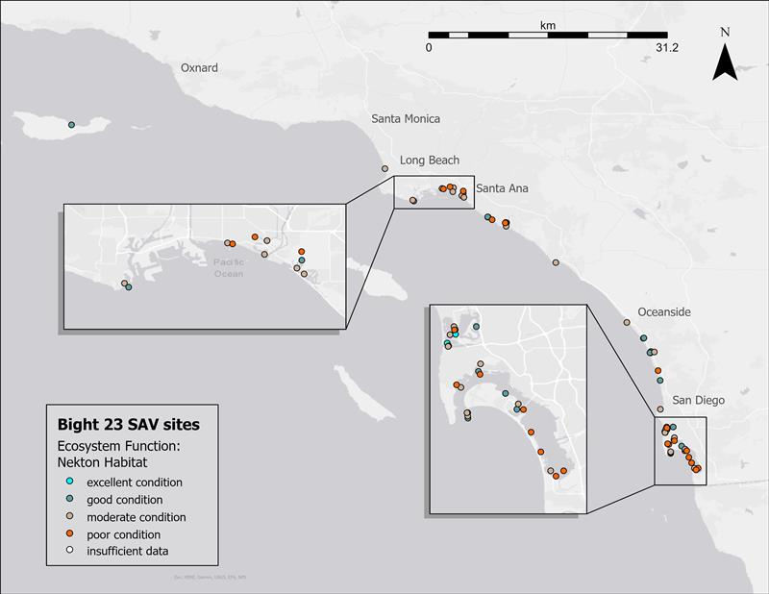
Figure C1. Geographic distribution of estimated nekton habitat ecosystem function throughout the Southern California Bight. The legend shows point color corresponding to overall eelgrass condition categories.
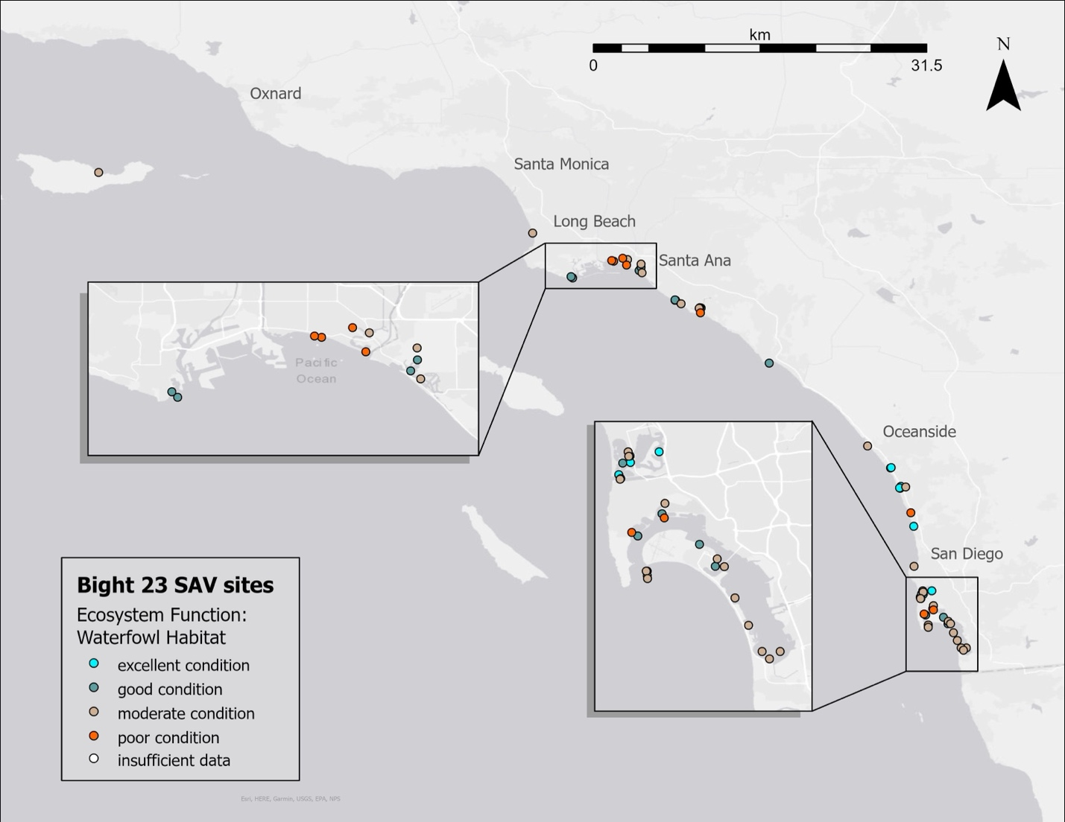
Figure C2. Geographic distribution of estimated waterfowl habitat ecosystem function throughout the Southern California Bight. The legend shows point color corresponding to overall eelgrass condition categories.
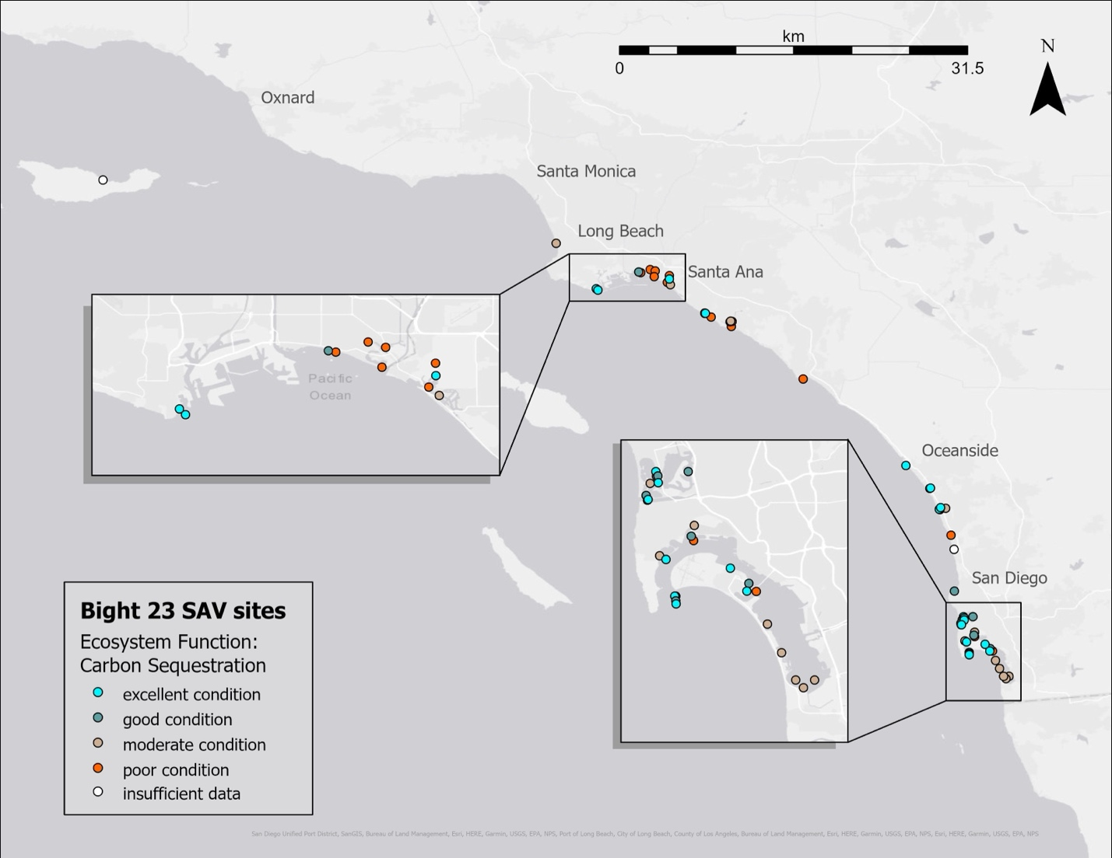
Figure C3. Geographic distribution of estimated carbon sequestration ecosystem function throughout the Southern California Bight. The legend shows point color corresponding to overall eelgrass condition categories.
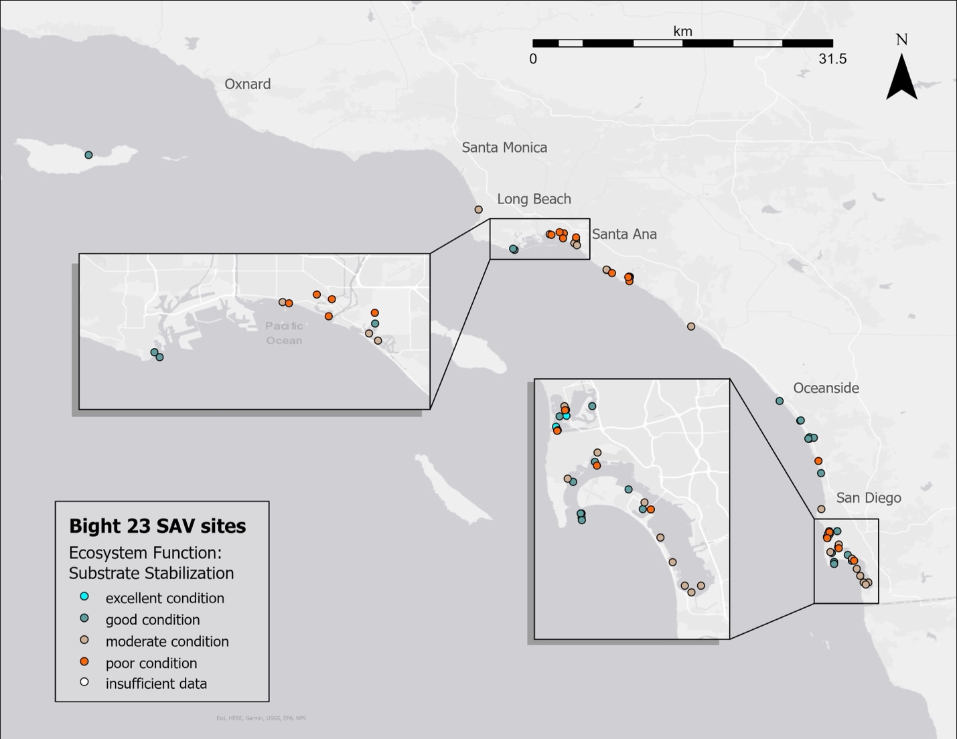
Figure C4. Geographic distribution of estimated substrate stabilization ecosystem function throughout the Southern California Bight. The legend shows point color corresponding to overall eelgrass condition categories.
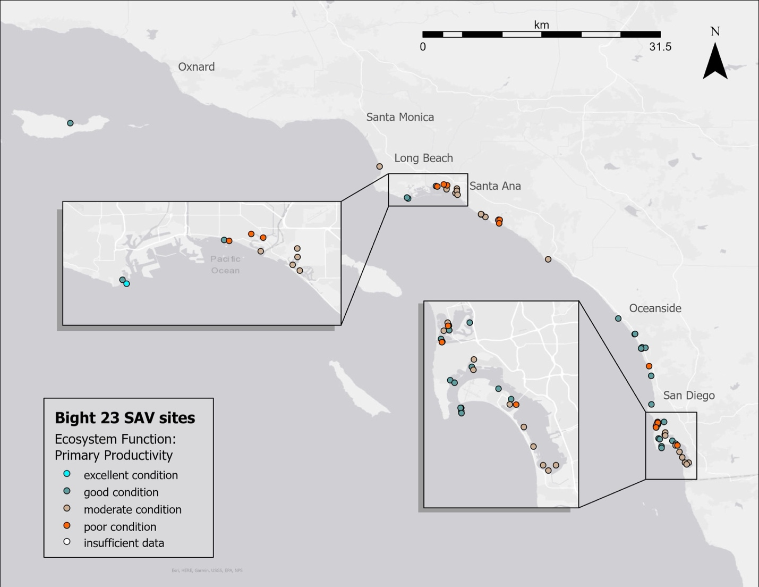
Figure C5. Geographic distribution of estimated primary production ecosystem function throughout the Southern California Bight. The legend shows point color corresponding to overall eelgrass condition categories.
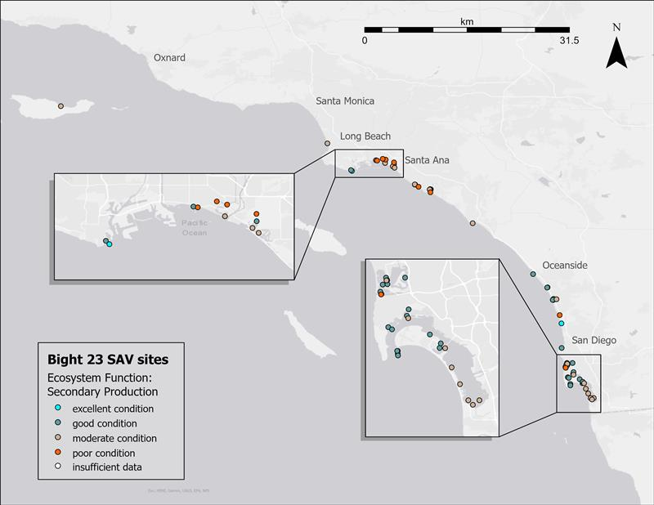
Figure C6. Geographic distribution of estimated secondary production ecosystem function throughout the Southern California Bight. The legend shows point color corresponding to overall eelgrass condition categories.

Appendix D – Exploratory Analyses
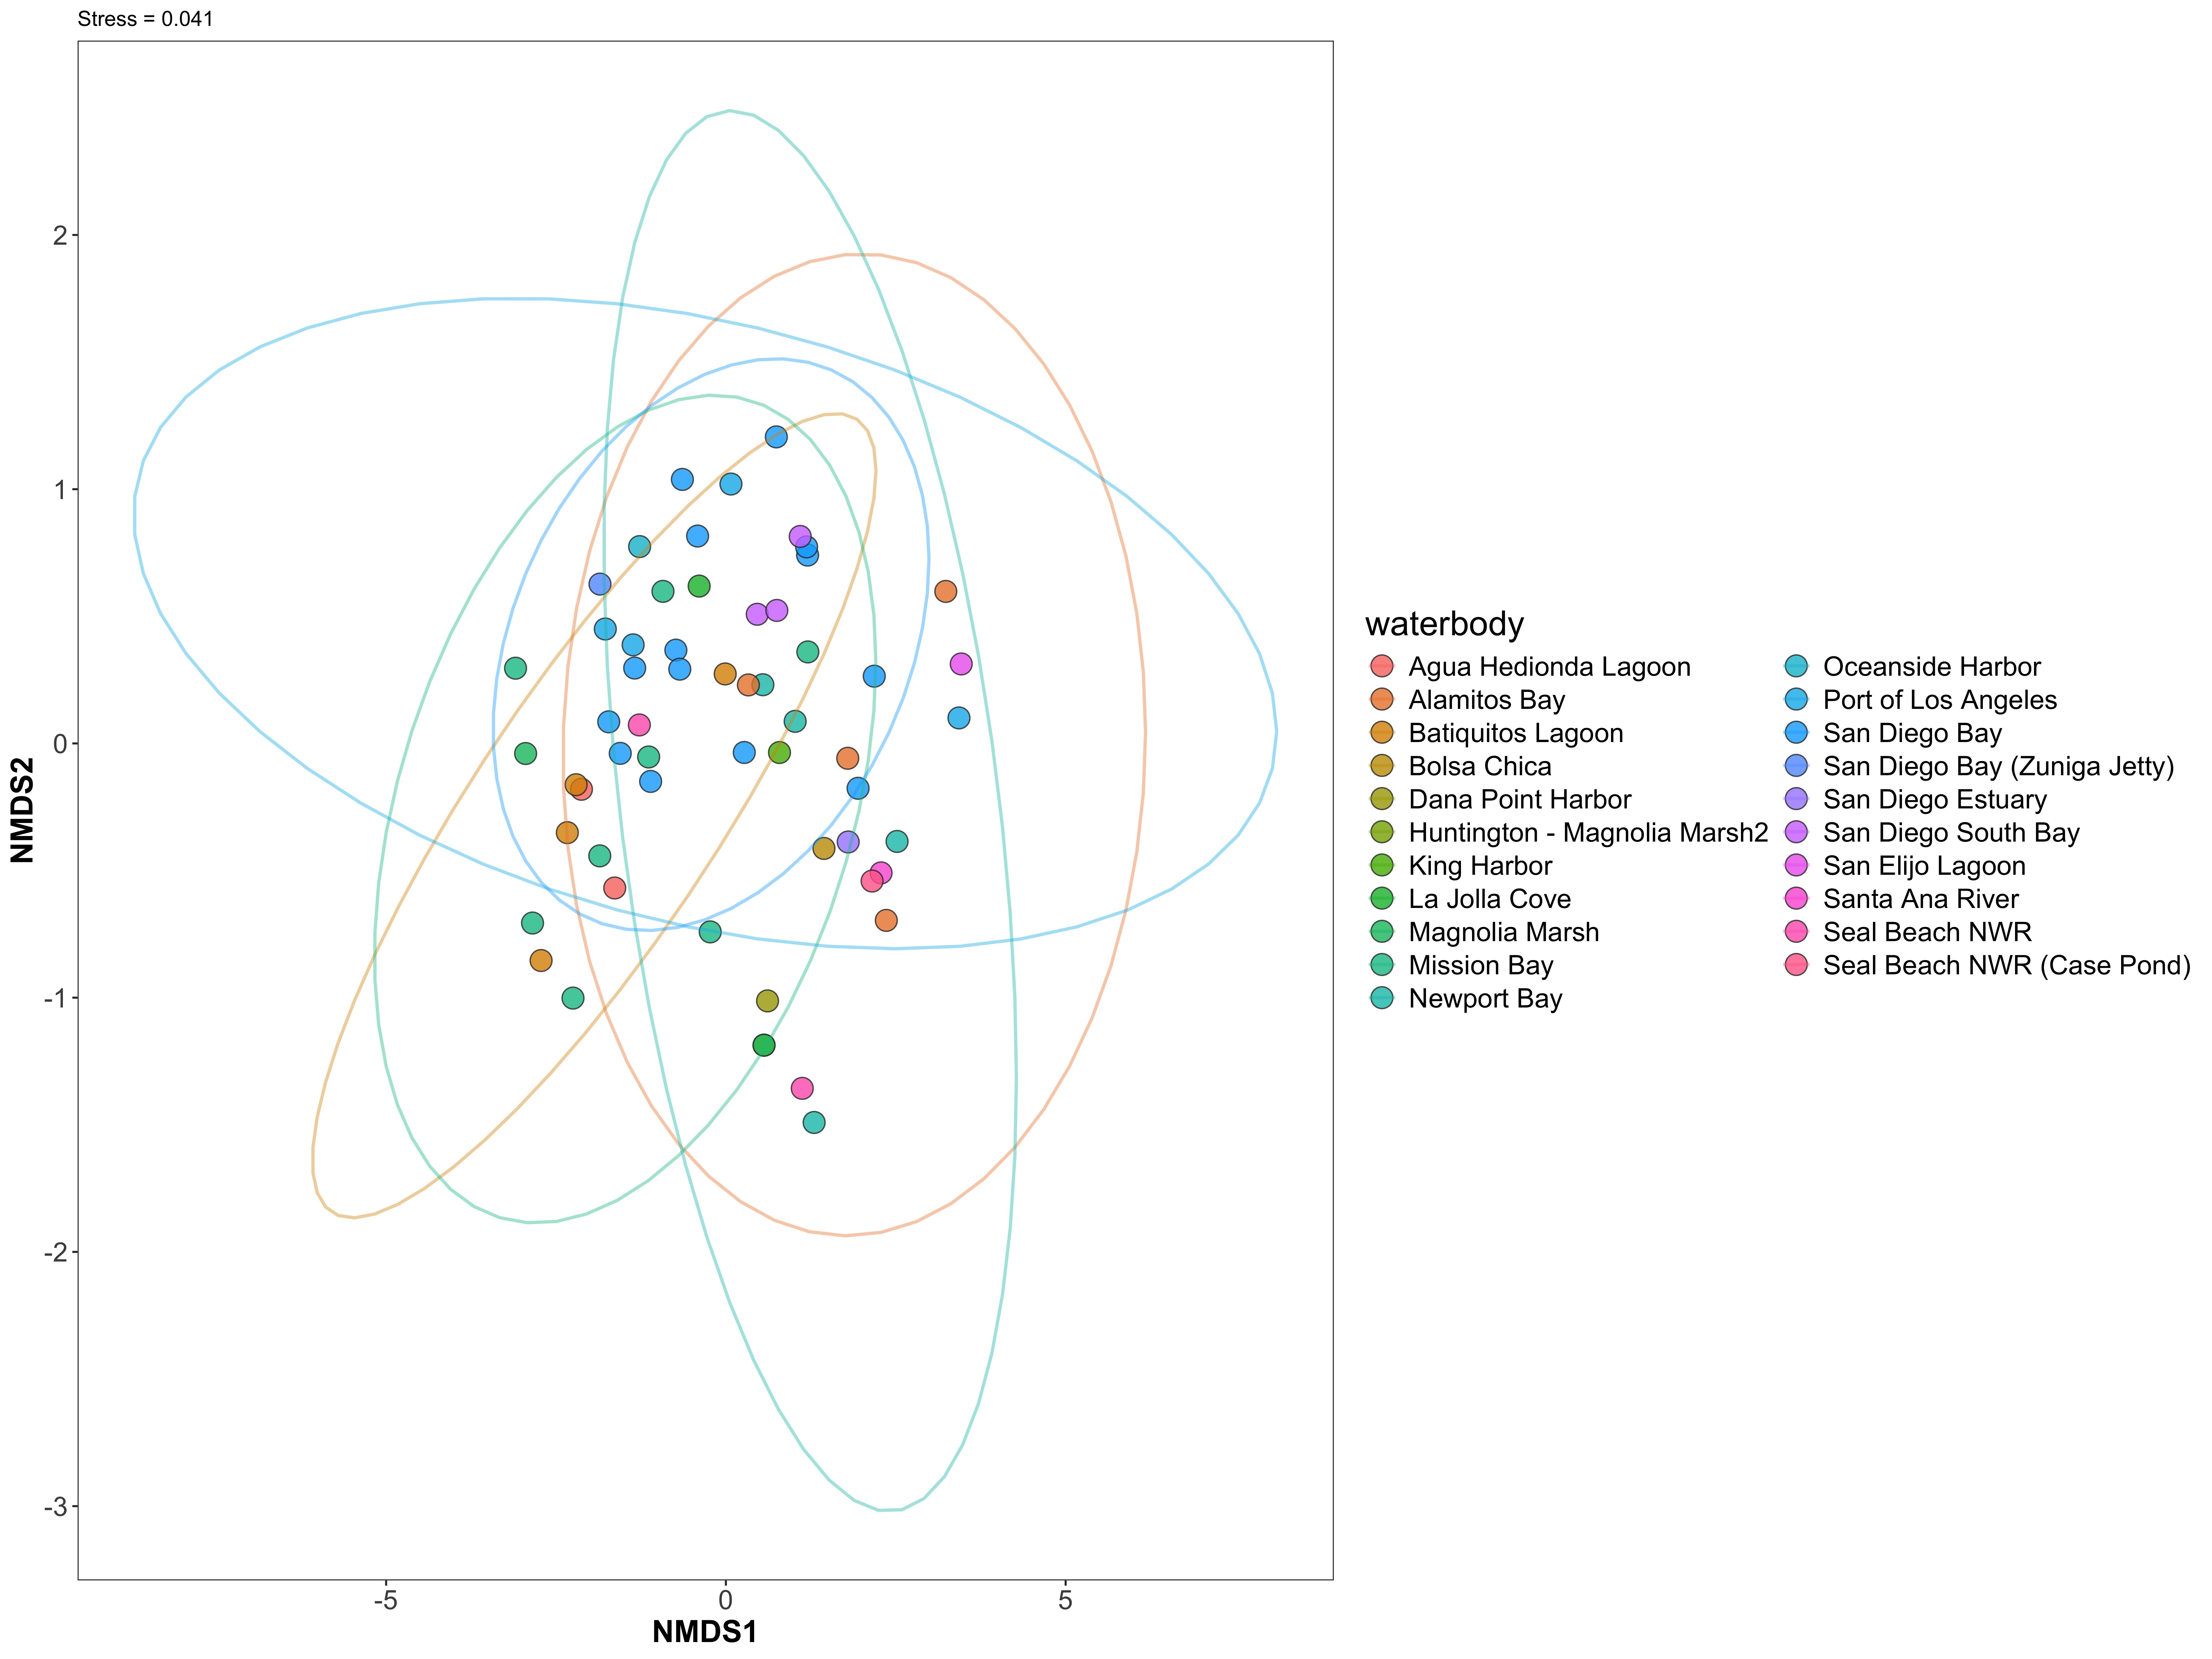
Figure D1. Two-dimensional non-metric multidimensional scaling (nMDS) ordination of ecosystem function scores at each site. Ellipses represent 95% of the data for each waterbody. Stress = 0.041.
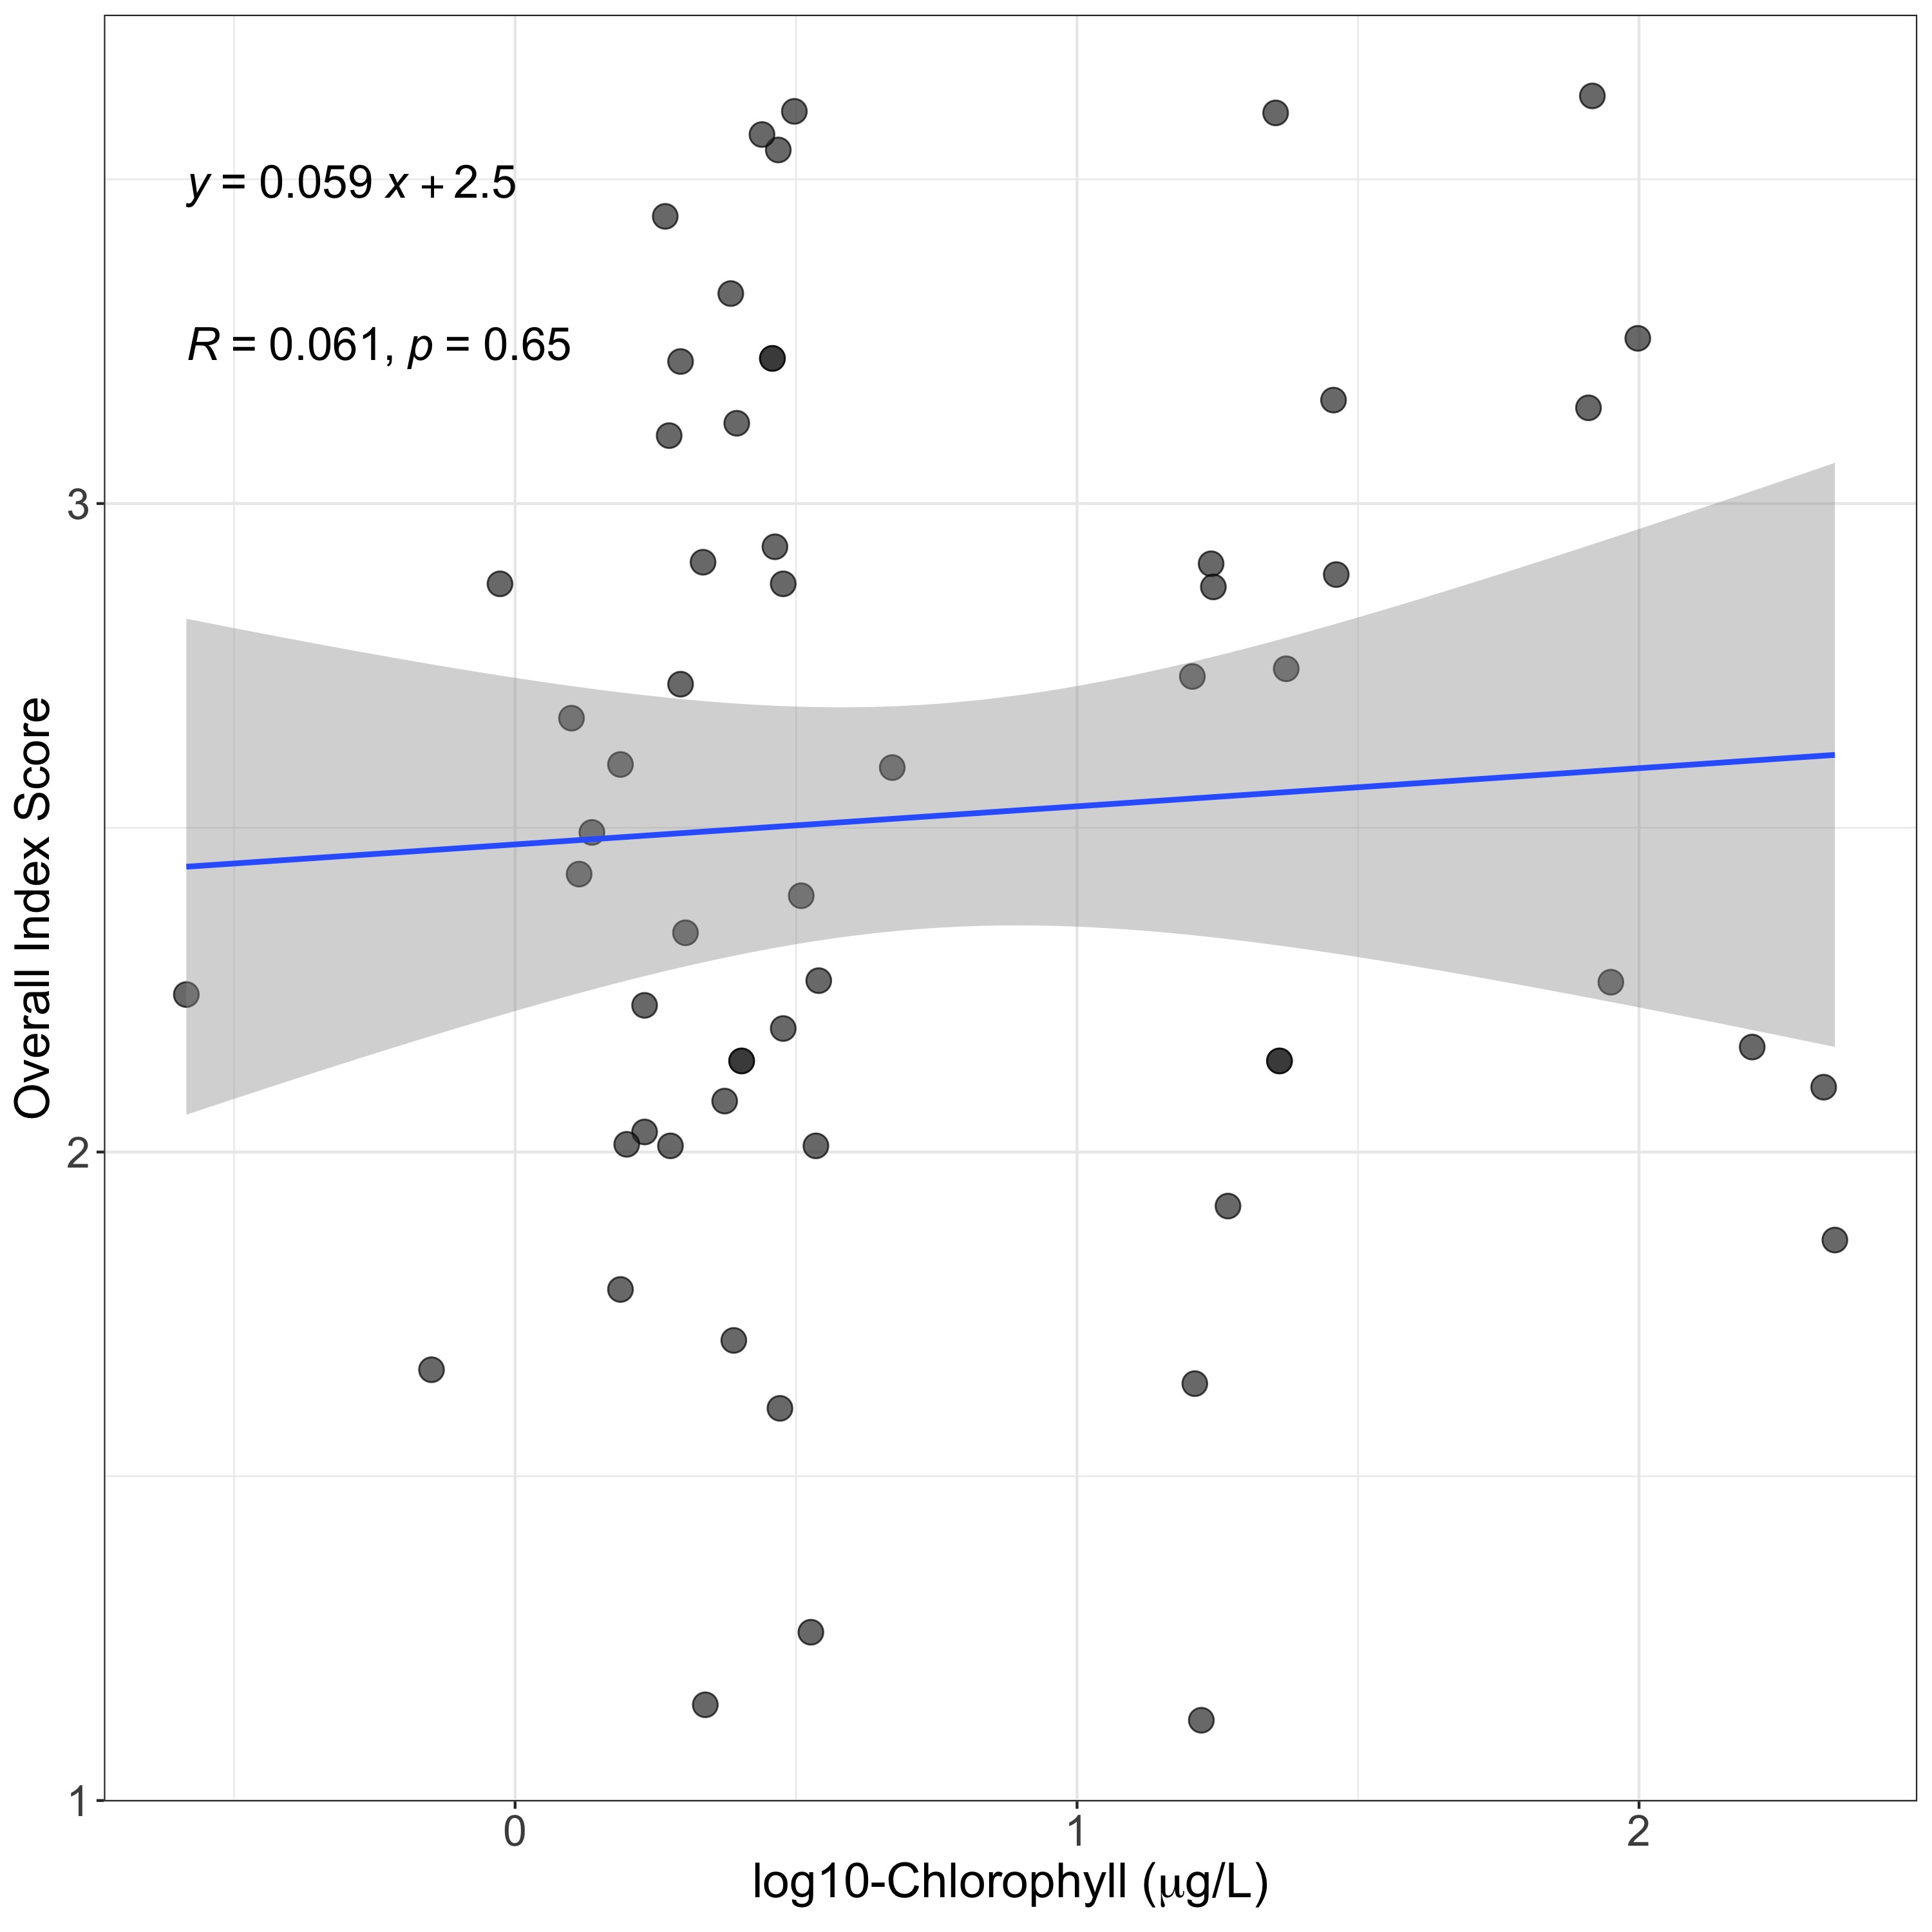
Figure D2. Log₁₀ – transformed chlorophyll a concentrations with overall eelgrass index scores. Chlorophyll data was not available for all sites. No significant relationship was observed.

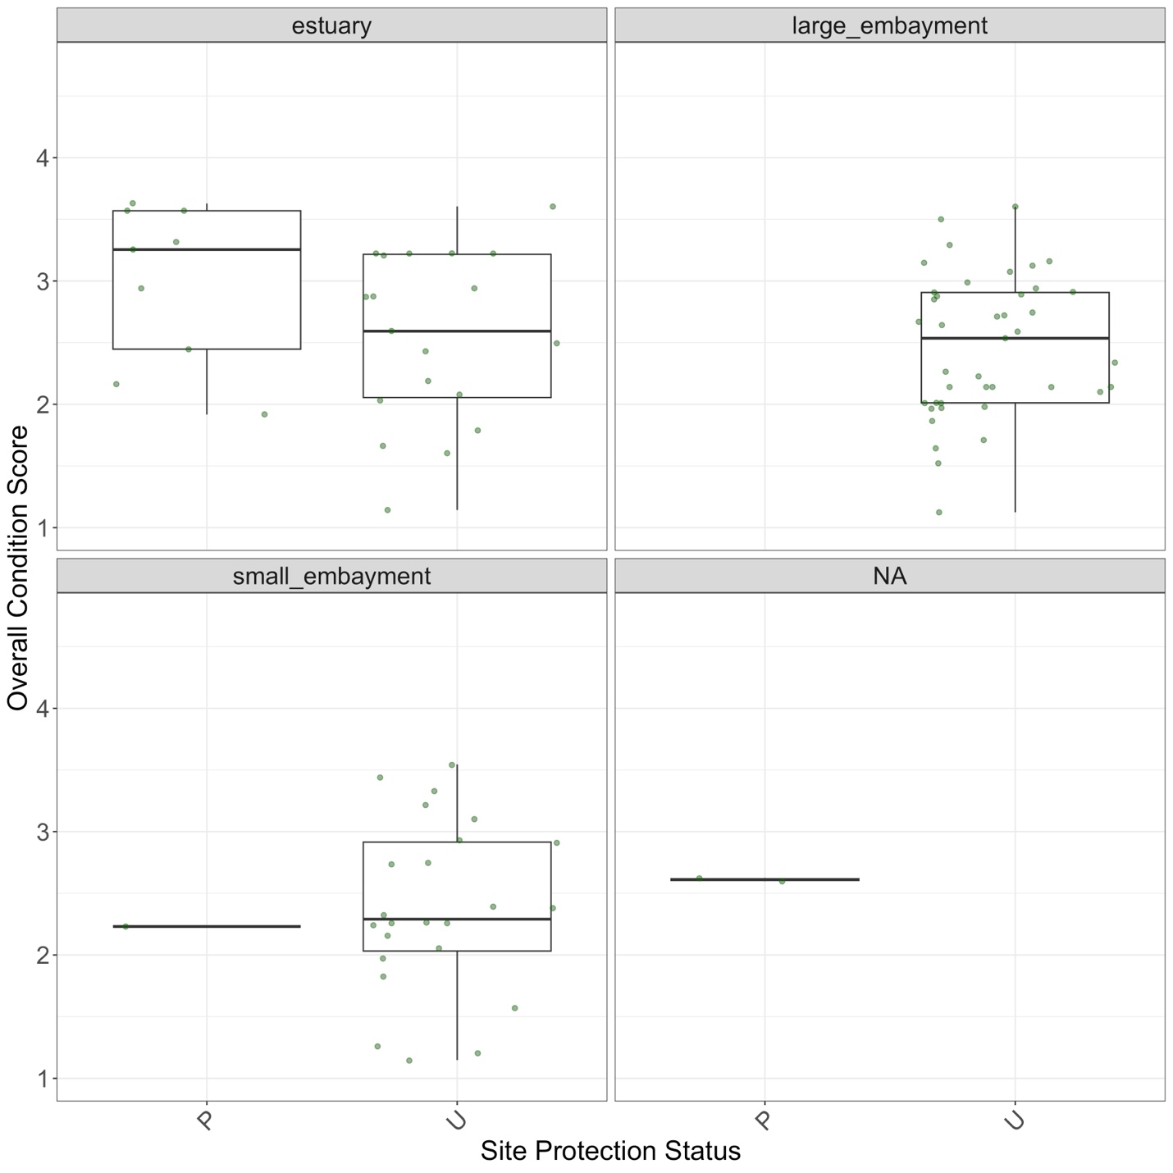
Figure D3. Overall eelgrass condition scores by nominal site protection status. P = “protected”, “U” = unprotected. Protected sites include areas within designated Marine Protected Areas (no take, limited take, State Marine Reserves, State Marine Conservation Areas). Unprotected sites are areas that are not protected from take in some way, including National Wildlife Refuges. T-test comparisons indicate no significant differences between protection status in any stratum.

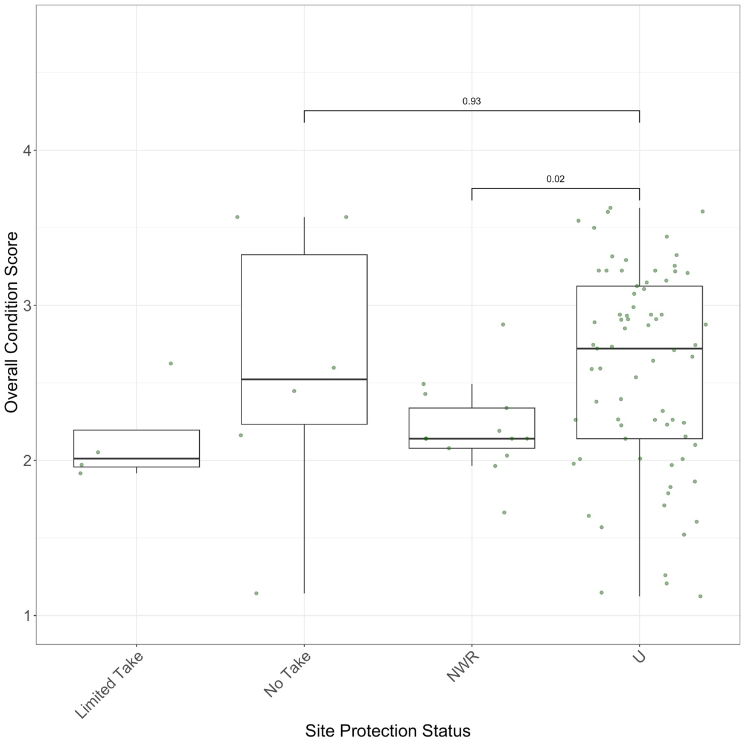
Figure D4. Overall eelgrass condition scores by specific site protection status. “No Take” = MPAs with no take, “Limited Take” = MPAs with limited take regulations, not including scientific collection, “NWR” = National Wildlife Refuges, “U” = unprotected. Wilcox test shows a significant (p = 0.02) difference between NWR and Unprotected sites.
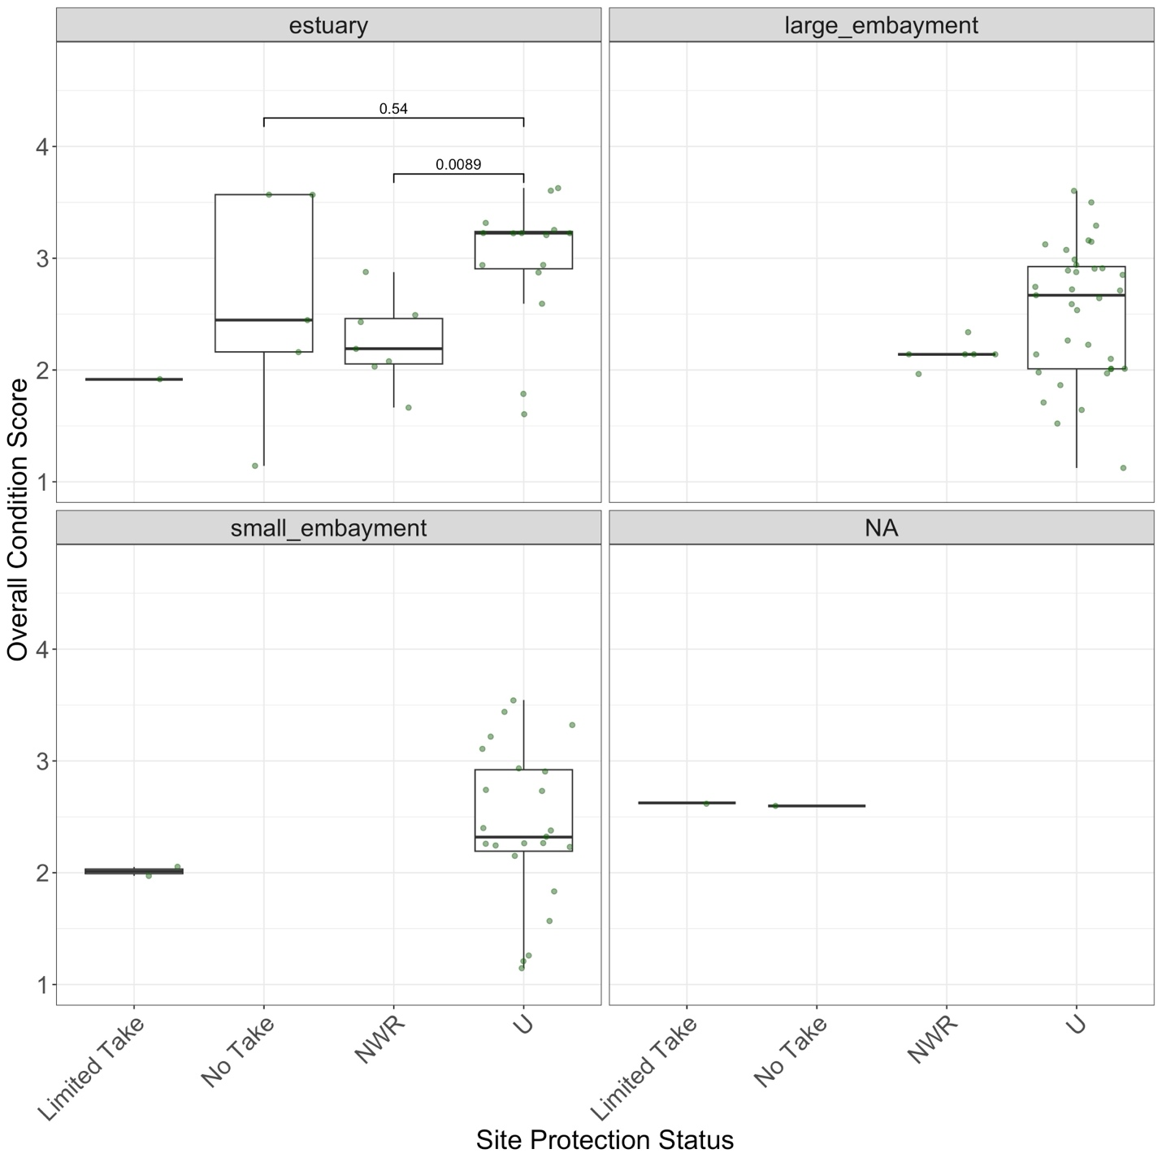
Figure D5. Overall eelgrass condition scores by specific site protection status. “No Take” = MPAs with no take, “Limited Take” = MPAs with limited take regulations, not including scientific collection, “NWR” = National Wildlife Refuges, “U” = unprotected. Wilcox test shows a significant (p = 0.0089) difference between NWR and Unprotected sites in estuaries only.

